
NICOSIA HEAD OFFICE
P.O.Box 21212, 1504 Nicosia. Cyprus
Tel: +357-22354744, Fax: +357-22354932
LIMASSOL OFFICE
Tel: +357-25589913, Fax: +357-25586407
e-mail: viometal@logosnet.cy.net
web: www.viometal.net
VIOMETAL LTD
A. V a r n a v i d e s
Manufacturing & Engineering

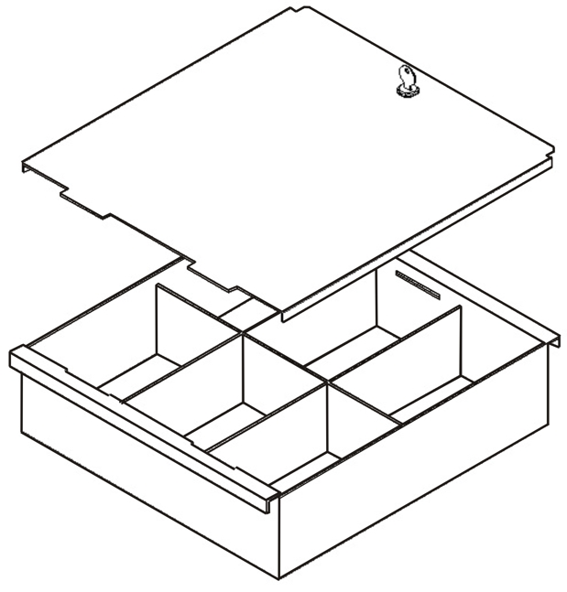
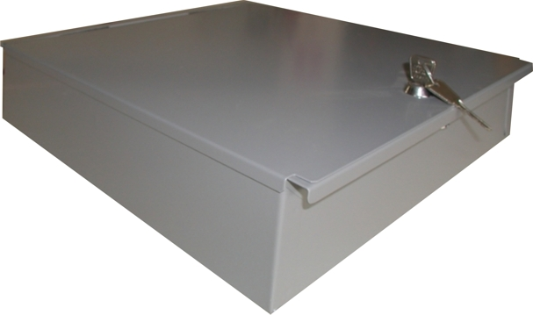
CASHIER BOX

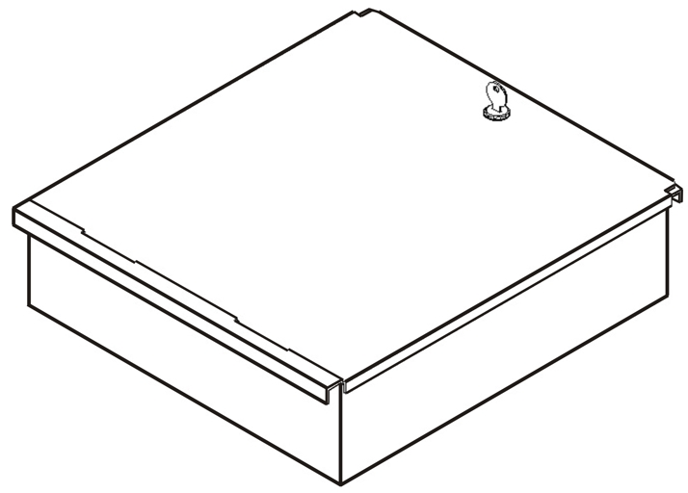

Code: CB3732
Dimensions: 37W x 32D x 9H
- Internal Separations
- Key Lock
Price: € 80.00 + VAT (=€ 93.60)

Ref. V068

SAFES 27
OFFICE FURNITURE, MOBILE SYSTEMS, STORAGE SYSTEMS, SHELVING SYSTEMS, SAFES & VAULTS

