
NICOSIA HEAD OFFICE
P.O.Box 21212, 1504 Nicosia. Cyprus
Tel: +357-22354744, Fax: +357-22354932
LIMASSOL OFFICE
Tel: +357-25589913, Fax: +357-25586407
Email: Viometal@logosnet.cy.net
Web: www.viometal.net
VIOMETAL LTD
A. V a r n a v i d e s
Manufacturing & Engineering

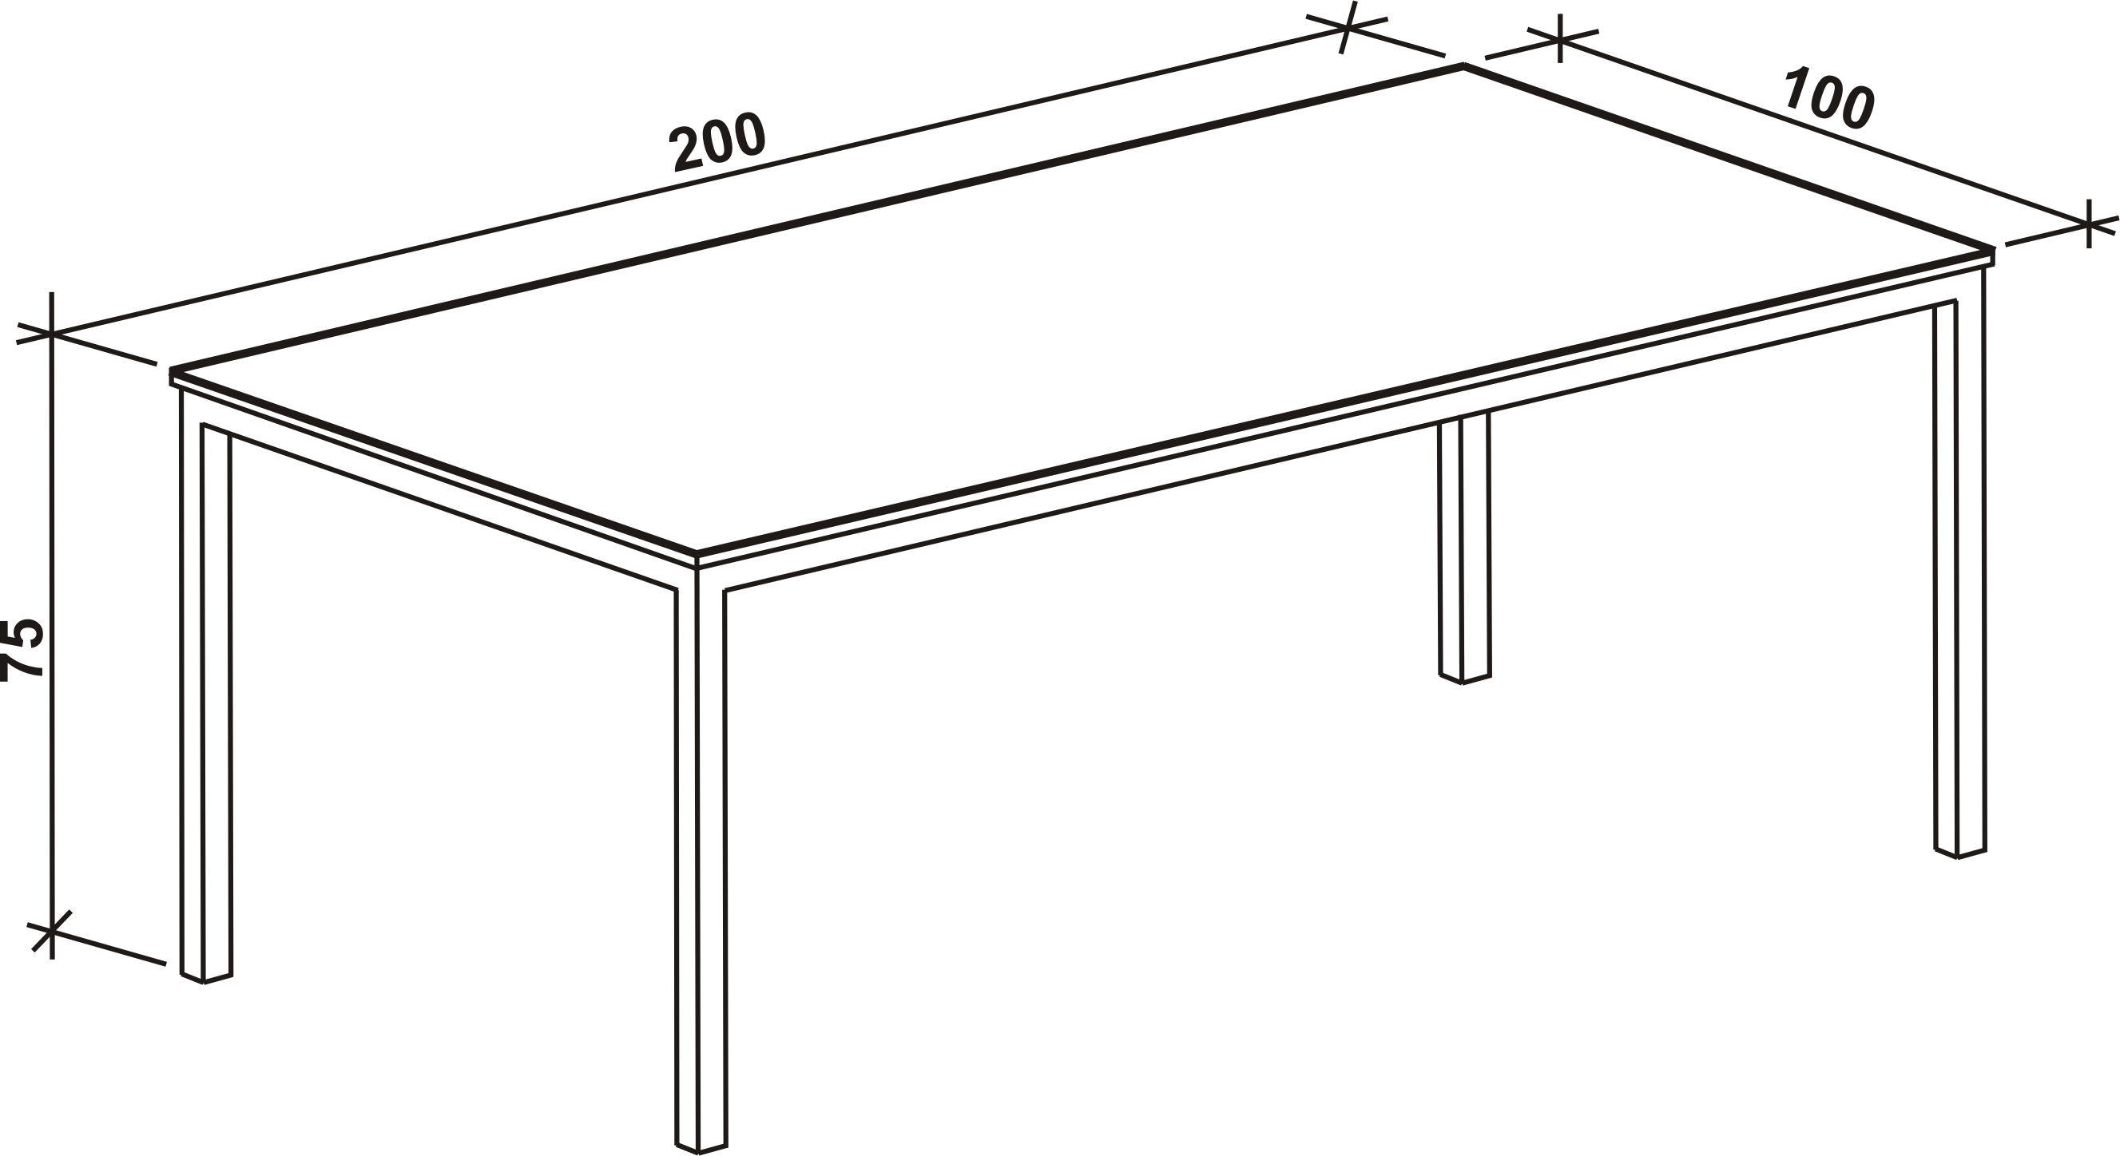
VIOMETAL CONFERENCE TABLE

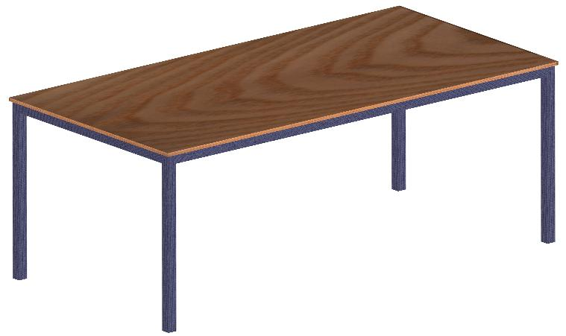

Code: VCONFT
Dimensions: 200L x 100D x 75H
- For 8 Persons
- Metal Frame with Melamine Top
Price: €350.00+VAT (=€409.50)

O/F 13

Ref. V067

OFFICE FURNITURE, MOBILE SYSTEMS, STORAGE SYSTEMS, SHELVING SYSTEMS, SAFES & VAULTS

