
NICOSIA HEAD OFFICE
P.O.Box 21212, 1504 Nicosia. Cyprus
Tel: +357-22354744, Fax: +357-22354932
LIMASSOL OFFICE
Tel: +357-25589913, Fax: +357-25586407
Email: Viometal@logosnet.cy.net
Web: www.viometal.net
VIOMETAL LTD
A. V a r n a v i d e s
Manufacturing & Engineering

ASH TRAY / WASTEPAPER BASCKET / DUST BINS

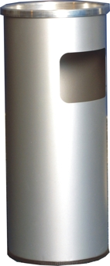

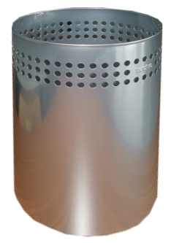

VIOMETAL WASTEPAPER BASCKET
Code: VWB
Price: €15.00+VAT (=€17.55)

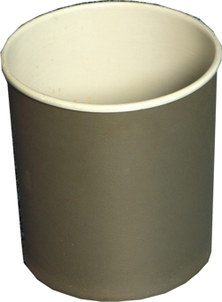


ASHTRAY 2T
Code: ASHTRAY2T
Price: €60.00+VAT (=€70.20)
DUST BIN
Code: VBINP
Viometal Painted Only
Price: €15.00+VAT (=€17.55)
DUST BIN (PVC)
Code: VBINPVC
Viometal Upholstered
Price: €20.00+VAT (=€23.40)

OTHER 11 - 13

Ref. V066

OFFICE FURNITURE, MOBILE SYSTEMS, STORAGE SYSTEMS, SHELVING SYSTEMS, SAFES & VAULTS

