
NICOSIA HEAD OFFICE
P.O.Box 21212, 1504 Nicosia. Cyprus
Tel: +357-22354744, Fax: +357-22354932
LIMASSOL OFFICE
Tel: +357-25589913, Fax: +357-25586407
Email: Viometal@logosnet.cy.net
Web: www.viometal.net
VIOMETAL LTD
A. V a r n a v i d e s
Manufacturing & Engineering

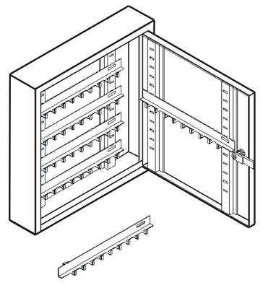

KEYBOX WALL CUPBOARDS
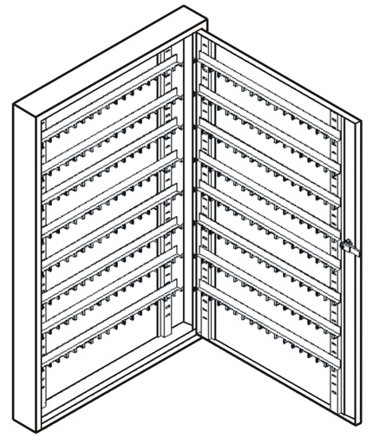
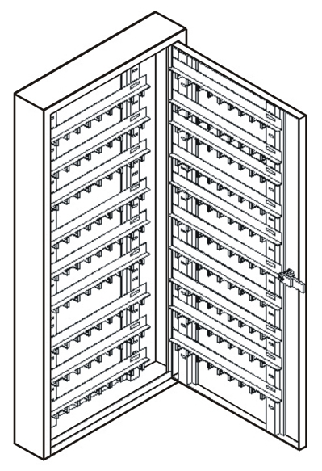

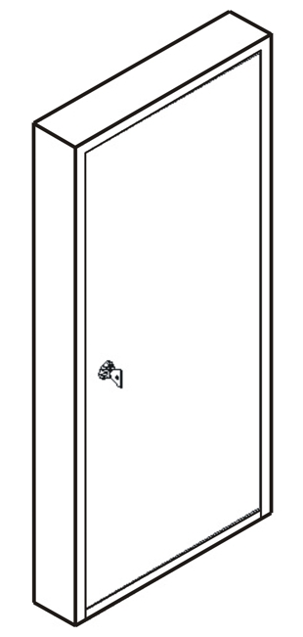

Code | Description / Dimensions | Price
KEYB50  KEYB100  KEYB300 | Keybox for 50 keys 32Wx7Dx34H  Keybox for 100 keys 32Wx7Dx68H  Keybox for 300 keys 50Wx7Dx80H | €85.00+VAT (=€99.45)  €125.00+VAT (=€146.25)  €175.00+VAT (=€204.75)

Ref. V065
OTHER 08

OFFICE FURNITURE, MOBILE SYSTEMS, STORAGE SYSTEMS, SHELVING SYSTEMS, SAFES & VAULTS

