
NICOSIA HEAD OFFICE
P.O.Box 21212, 1504 Nicosia. Cyprus
Tel: +357-22354744, Fax: +357-22354932
LIMASSOL OFFICE
Tel: +357-25589913, Fax: +357-25586407
Email: Viometal@logosnet.cy.net
Web: www.viometal.net
VIOMETAL LTD
A. V a r n a v i d e s
Manufacturing & Engineering

STOOLS

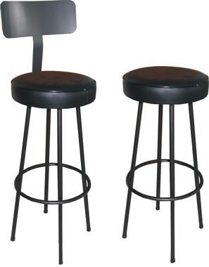

Code | Description | Price
CH137 | Without Back Rest | €43.00+VAT (=€50.31)
CH138 | With Back Rest | €60.00+VAT (=€70.20)

Ref. V063
CH 10

OFFICE FURNITURE, MOBILE SYSTEMS, STORAGE SYSTEMS, SHELVING SYSTEMS, SAFES & VAULTS

