
NICOSIA HEAD OFFICE
P.O.Box 21212, 1504 Nicosia. Cyprus
Tel: +357-22354744, Fax: +357-22354932
LIMASSOL OFFICE
Tel: +357-25589913, Fax: +357-25586407
Email: Viometal@logosnet.cy.net
Web: www.viometal.net
VIOMETAL LTD
A. V a r n a v i d e s
Manufacturing & Engineering

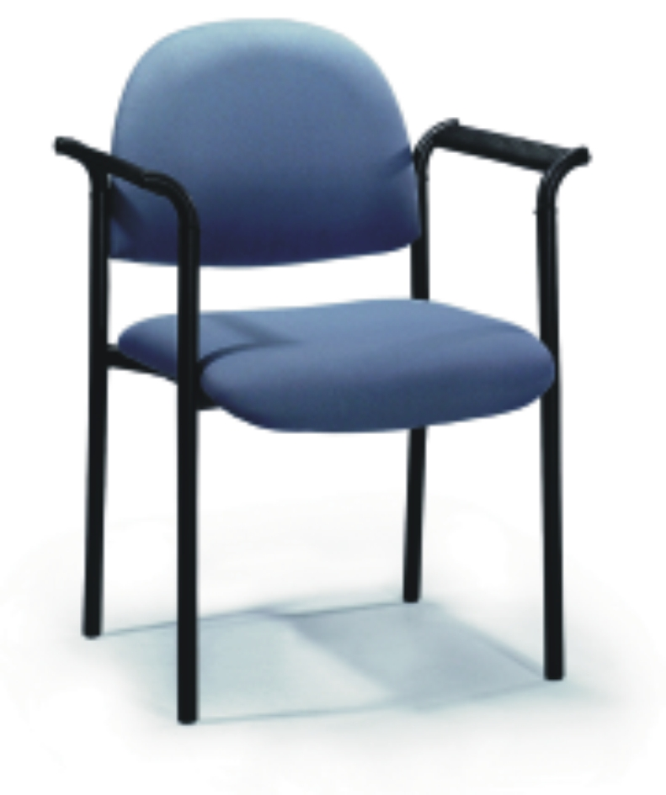
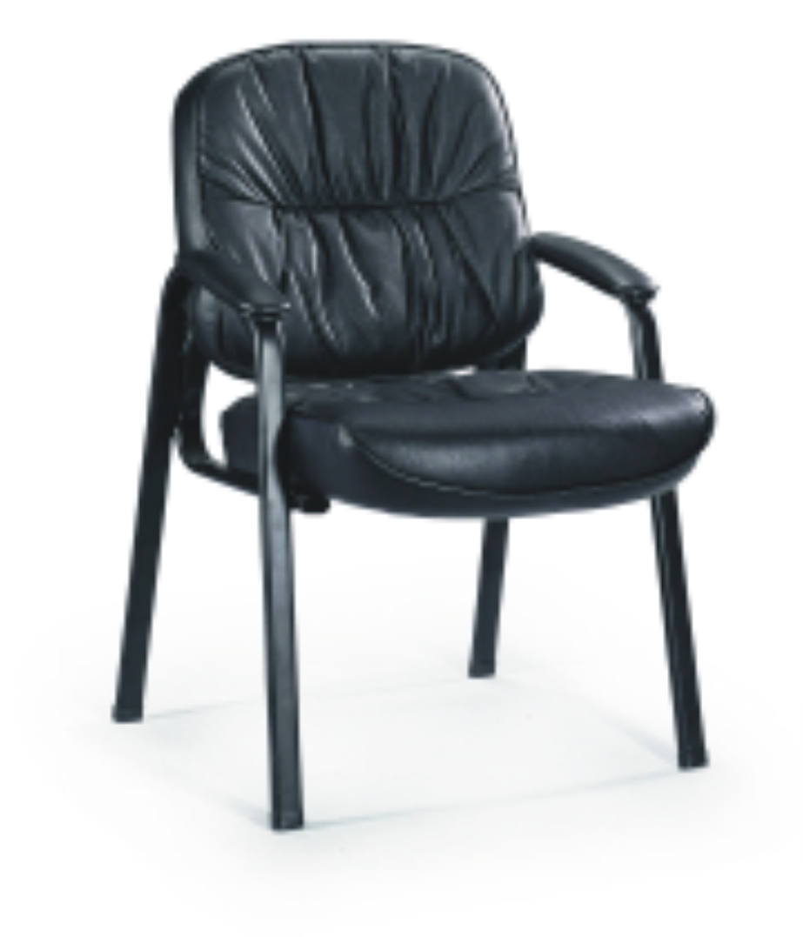

CHAIRS

Code: CHD099A01
L/B Leather Visitor
Price:
€150.00+VAT (=€175.50)

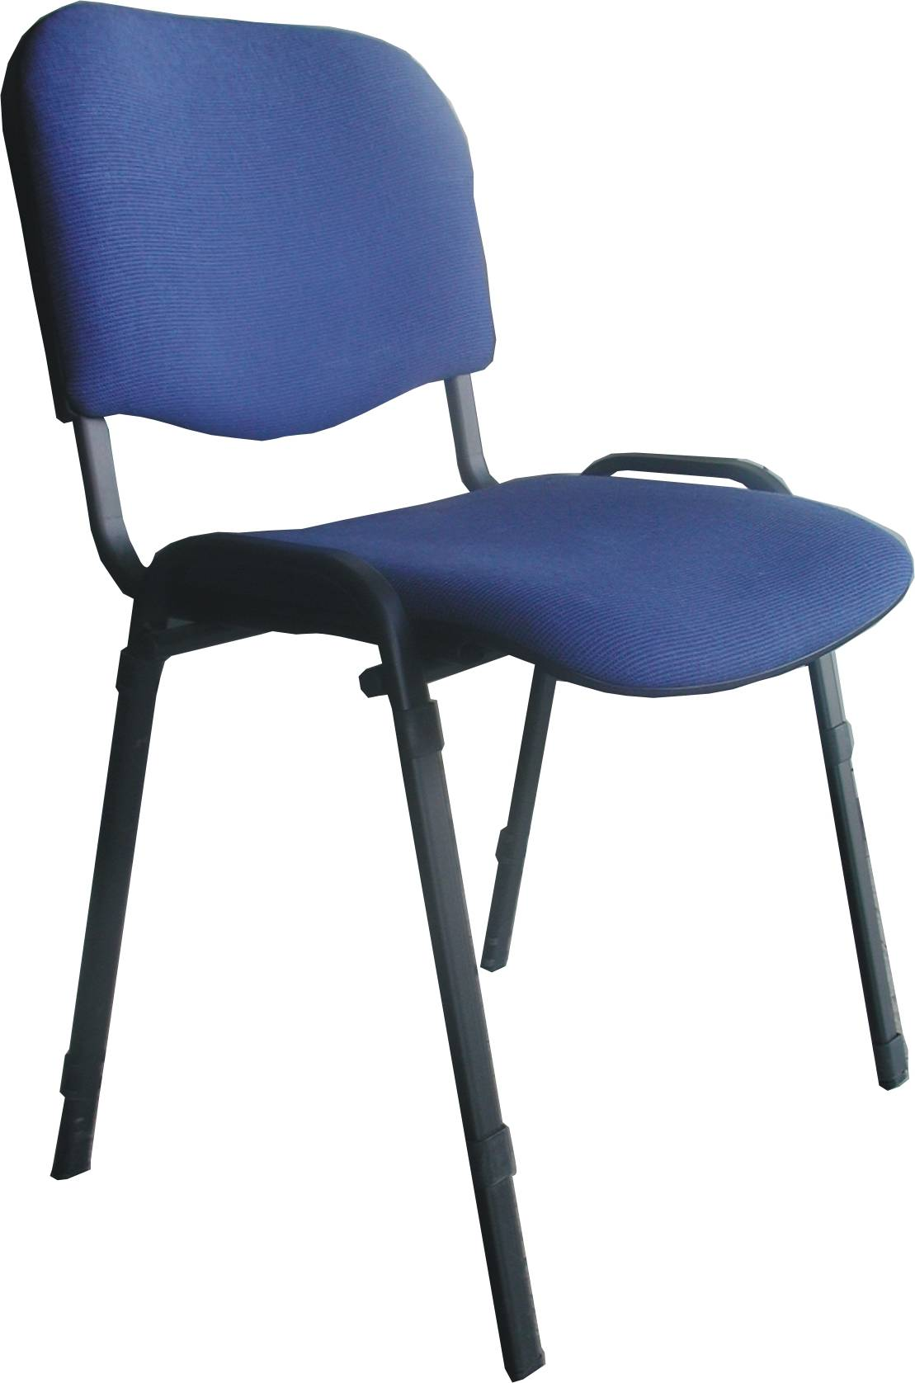
Code: CHD062A01
L/B Fabric Visitor Chair With Arms
Price:€55.00+VAT (=€64.35)

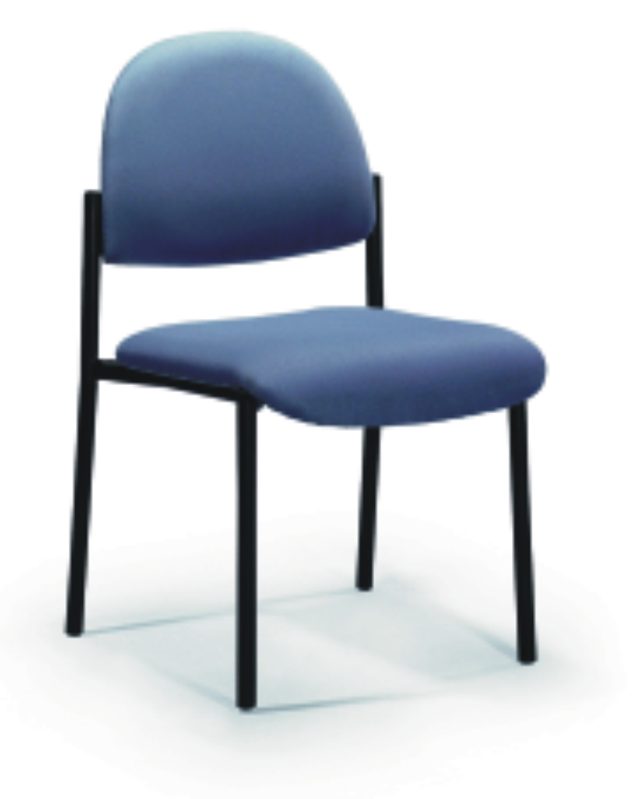

ISO – Visitor
Code: CH118
Without arms
Price:
€60.00+VAT (=€70.20)

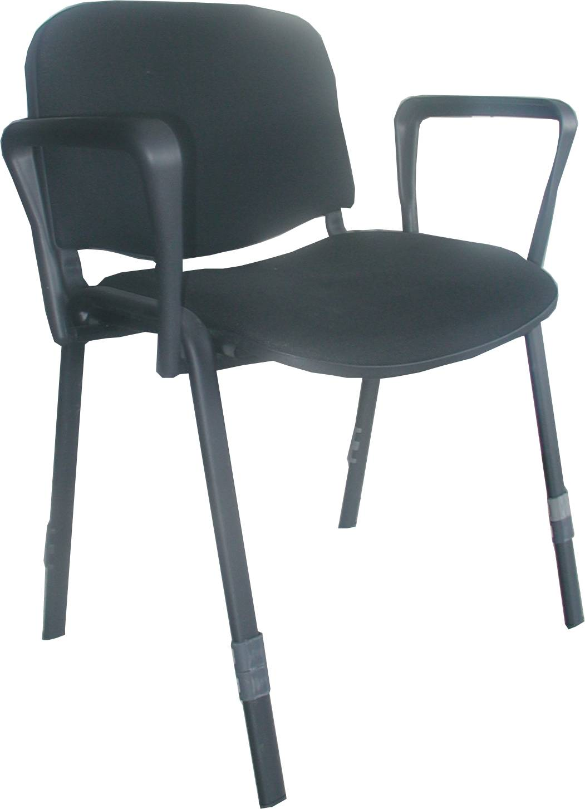

Code: CHD063A01
L/B Fabric Visitor Chair Without Arms
Price: €45.00+VAT (=€52.65)

.

ISO – Visitor
Code: CH117
With arms
Price:€75.00 + VAT (=€87.75)

CH 04 - 08
Ref: V061

OFFICE FURNITURE, MOBILE SYSTEMS, STORAGE SYSTEMS, SHELVING SYSTEMS, SAFES & VAULTS

