
NICOSIA HEAD OFFICE
P.O.Box 21212, 1504 Nicosia. Cyprus
Tel: +357-22354744, Fax: +357-22354932
LIMASSOL OFFICE
Tel: +357-25589913, Fax: +357-25586407
Email: Viometal@logosnet.cy.net
Web: www.viometal.net
VIOMETAL LTD
A. V a r n a v i d e s
Manufacturing & Engineering

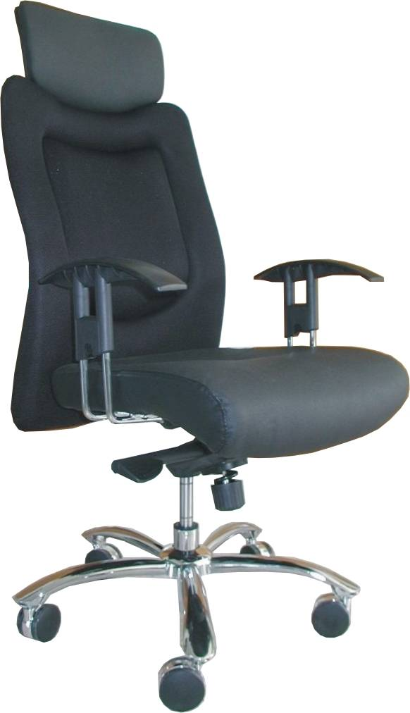

CHAIRS

Code: CHA065C02
H/B Leather/Mesh Fabric
Synch. Mechanism &
Height Adjustable Arms
Price: €260.00 + VAT (=€304.20)

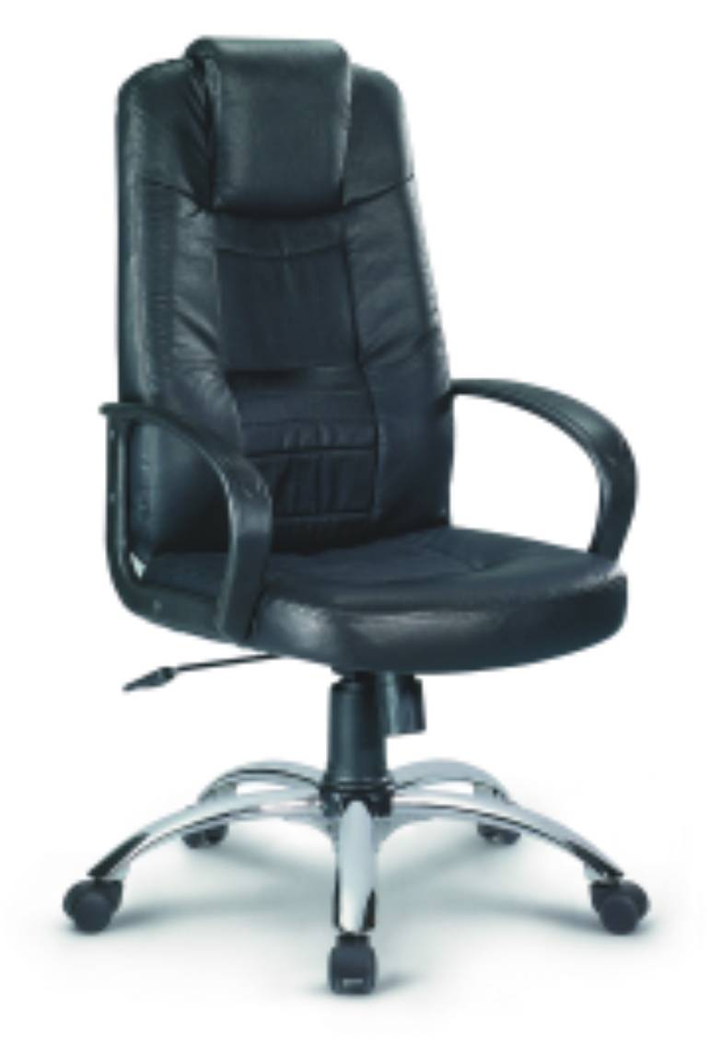

Code: CHA066A02
H/B Leather Manager
Synch. Mechanism with Arms
Price: €210.00 + VAT (=€245.70)

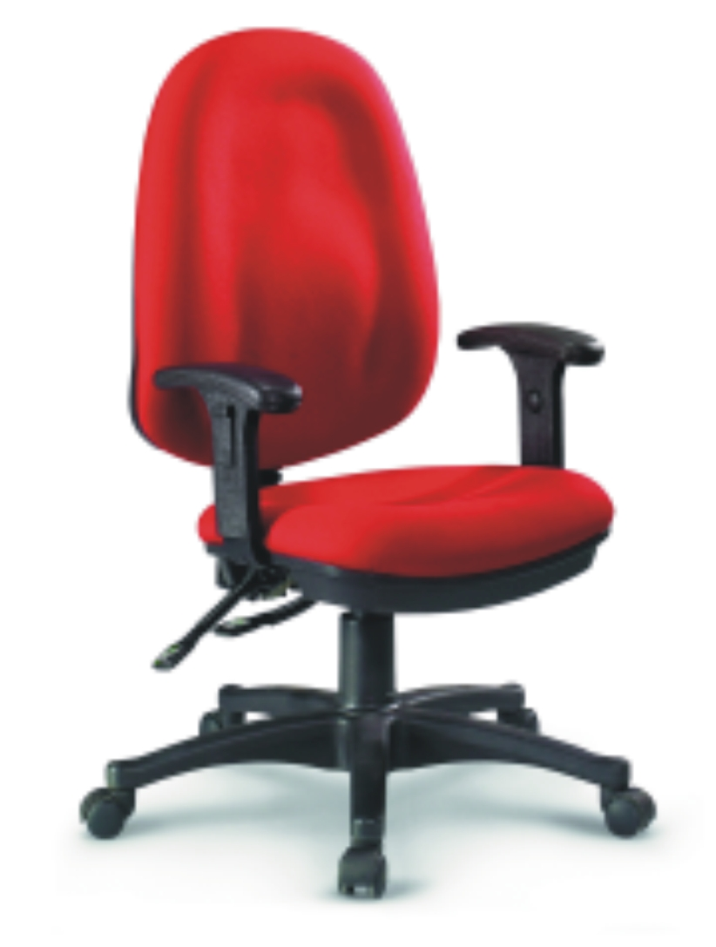

Code: CHA125A06
L/B Fabric Executive
Synch. Mechanism &
Height Adjustable Arms
Price:€150.00 + VAT (=€175.50)

CH 01 - 03
Ref: V060

OFFICE FURNITURE, MOBILE SYSTEMS, STORAGE SYSTEMS, SHELVING SYSTEMS, SAFES & VAULTS

