
NICOSIA HEAD OFFICE
P.O.Box 21212, 1504 Nicosia. Cyprus
Tel: +357-22354744, Fax: +357-22354932
LIMASSOL OFFICE
Tel: +357-25589913, Fax: +357-25586407
Email: Viometal@logosnet.cy.net
Web: www.viometal.net
VIOMETAL LTD
A. V a r n a v i d e s
Manufacturing & Engineering

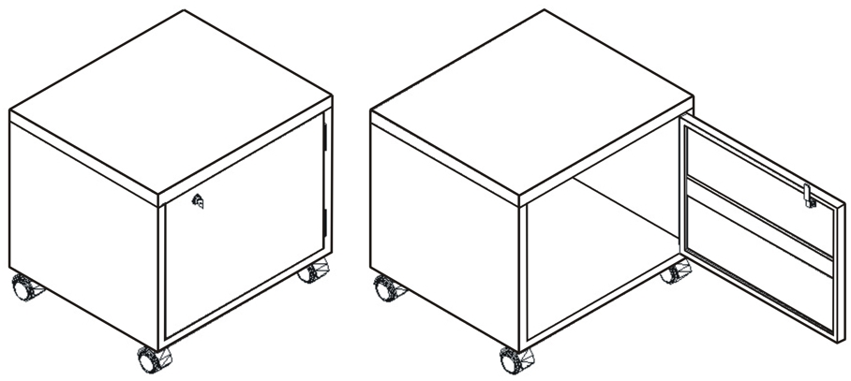

Cupboard/Stand for
Photocopy Machine

Ref: V059

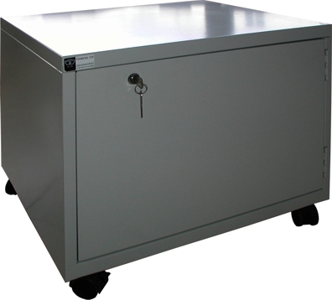
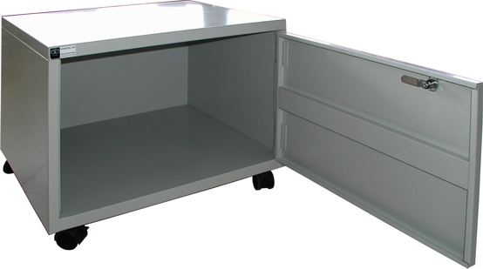

Code: PHOTO
Dim: 58W x 50D x (45+7)H
With Castors
Price: €160.00 + VAT (=€187.20)

Ref. V059
L&C 12
OFFICE FURNITURE, MOBILE SYSTEMS, STORAGE SYSTEMS, SHELVING SYSTEMS, SAFES & VAULTS

