
NICOSIA HEAD OFFICE
P.O.Box 21212, 1504 Nicosia. Cyprus
Tel: +357-22354744, Fax: +357-22354932
LIMASSOL OFFICE
Tel: +357-25589913, Fax: +357-25586407
Email: Viometal@logosnet.cy.net
Web: www.viometal.net
VIOMETAL LTD
A. V a r n a v i d e s
Manufacturing & Engineering

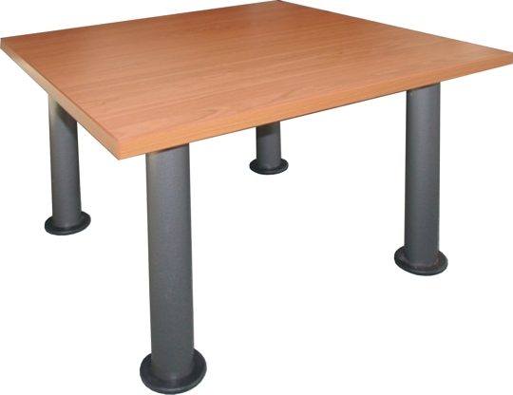
COFFEE TABLE

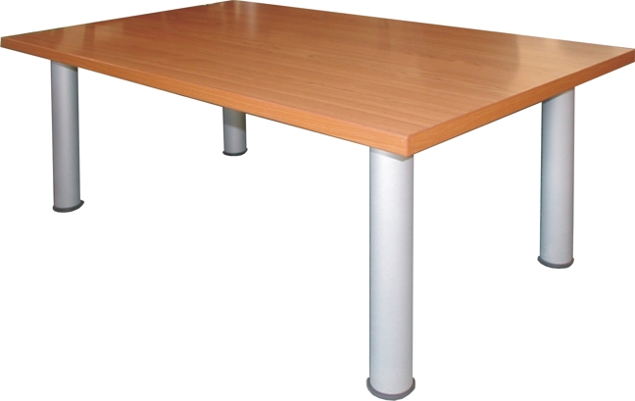
Code: CT60W
Dim: 60W x 60D x 40H
Wooden Top with Metal Legs
Price: €100.00 + VAT (=€117.00)
Code: CT90W
Dim: 90W x 60D x 40H
Wooden Top with Metal Legs
Price: €110.00+VAT (=€128.70)

Ref. V058
O/F 10 & 11
OFFICE FURNITURE, MOBILE SYSTEMS, STORAGE SYSTEMS, SHELVING SYSTEMS, SAFES & VAULTS

