
O/F 06
NICOSIA HEAD OFFICE
P.O.Box 21212, 1504 Nicosia. Cyprus
Tel: +357-22354744, Fax: +357-22354932
LIMASSOL OFFICE
Tel: +357-25589913, Fax: +357-25586407
Email: Viometal@logosnet.cy.net
Web: www.viometal.net
VIOMETAL LTD
A. V a r n a v i d e s
Manufacturing & Engineering

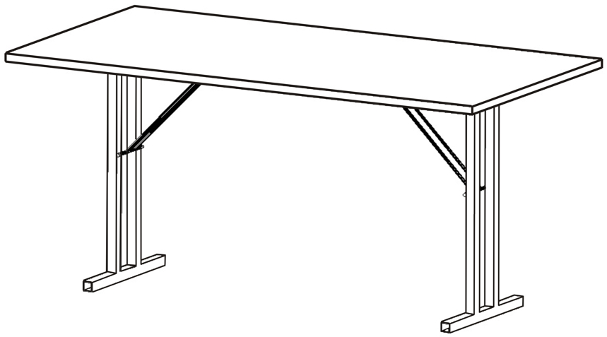
FOLDING TABLE

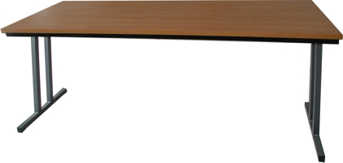

Code | Description | Dim.s | Price
FDCOP | FOLDING TABLE WITH PAINTED LEGS & FRAME, WOOD MELAMINE TOP | 160 x 60 | €170.00+VAT (=€198.90)
FD80/P | FOLDING TABLE WITH PAINTED LEGS & FRAME, WOOD MELAMINE TOP | 160 x 80 | €190.00+VAT (=€222.30)

Ref. V056

OFFICE FURNITURE, MOBILE SYSTEMS, STORAGE SYSTEMS, SHELVING SYSTEMS, SAFES & VAULTS

