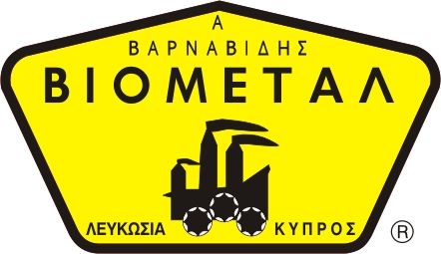
O/F 04,05
NICOSIA HEAD OFFICE
P.O.Box 21212, 1504 Nicosia. Cyprus
Tel: +357-22354744, Fax: +357-22354932
LIMASSOL OFFICE
Tel: +357-25589913, Fax: +357-25586407
Email: Viometal@logosnet.cy.net
Web: www.viometal.net
VIOMETAL LTD
A. V a r n a v i d e s
Manufacturing & Engineering
PYTHAGORAS CONFERENCE
ROUND CHERRY
PYTHAGORAS CONFERENCE
OVAL CHERRY

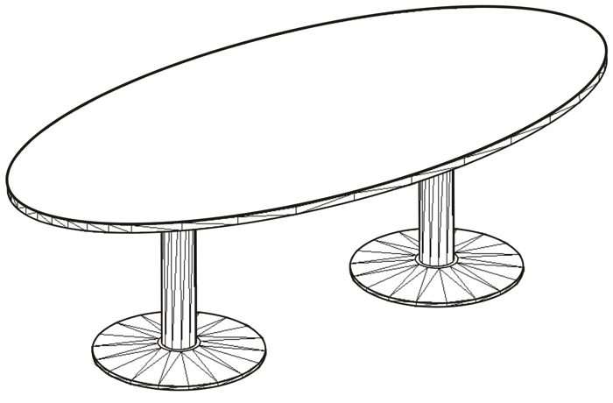
Code: CONF120
Round Conference Table
Dimensions: Ø120 x 72H
Price: €290.00+VAT (=€339.30)

Code: CONF140
Round Conference Table
Dimension: Ø140 x 72H
Price: €340.00+VAT (=€397.80)
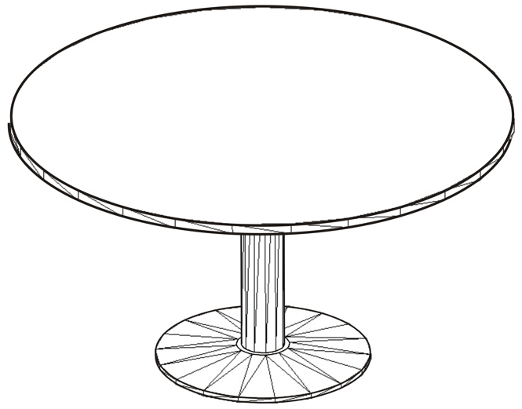

Code: CONF240
Oval Conference Table
Dimensions: 240W x 120D x 72H
Price: €480.00+VAT (=€561.60)

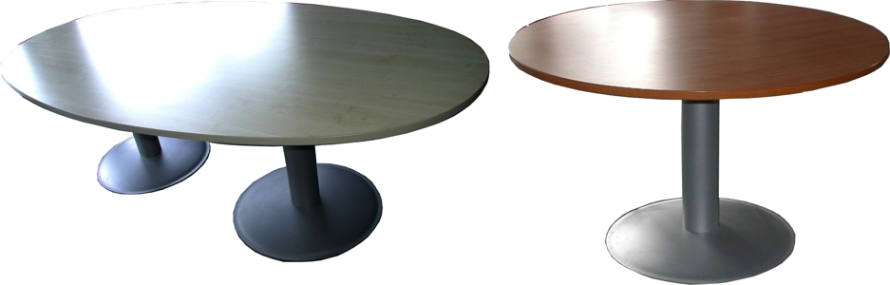

Ref. V055

OFFICE FURNITURE, MOBILE SYSTEMS, STORAGE SYSTEMS, SHELVING SYSTEMS, SAFES & VAULTS

