
VIOMETAL LTD
A. V a r n a v i d e s
Manufacturing & Engineering
NICOSIA HEAD OFFICE
P.O.Box 21212, 1504 Nicosia. Cyprus
Tel: +357-22354744, Fax: +357-22354932
LIMASSOL OFFICE
Tel: +357-25589913, Fax: +357-25586407
Email: Viometal@logosnet.cy.net
Web: www.viometal.net

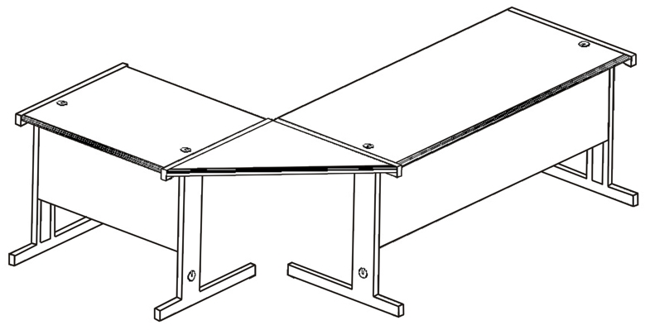

VIOMODULAR - DESKS
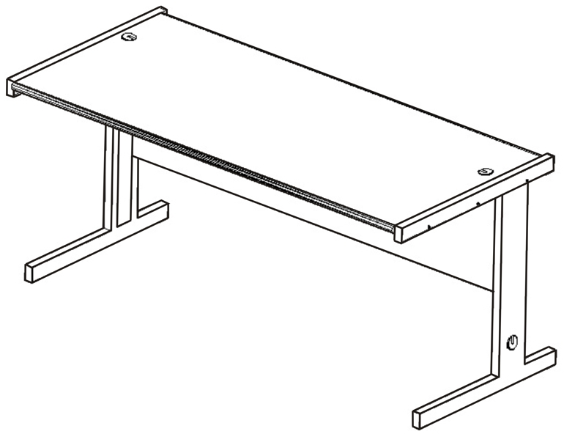

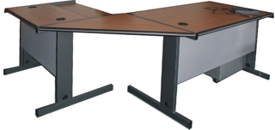

Ref. V054

CODE | DESCRIPTION | DIMENSIONS | PRICE
VIOM90  VIOM120  VIOM140  VIOM160  VIOM180  VIOMCOMP  VIOMANGLE | HEAVY DUTY OFFICE DESK  - WIRE MANAGEMENT  - 30 MM MELAMINE TOP  - METAL FRAME AND  MODESTY PANEL  COMPUTER TABLE  CONNECTING ANGLE | 90W X 75D X 75H  120W X 75D X 75H  140W X 75D X 75H  160W X 75D X 75H  180W X 75D X 75H  90W x 75D x 75H  120W X 75D | €180.00 + VAT (=€210.60)  €200.00 + VAT (=€234.00)  €210.00 + VAT (=€245.70)  €220.00 + VAT (=€257.40)  €230.00 + VAT (=€269.10)  €195.00 + VAT (=€228.15)  €60.00 + VAT (=€70.20)
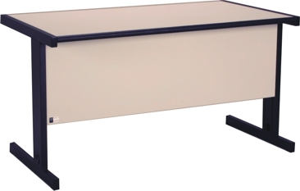

O/F 03
OFFICE FURNITURE, MOBILE SYSTEMS, STORAGE SYSTEMS, SHELVING SYSTEMS, SAFES & VAULTS

