
NICOSIA HEAD OFFICE
P.O.Box 21212, 1504 Nicosia. Cyprus
Tel: +357-22354744, Fax: +357-22354932
LIMASSOL OFFICE
Tel: +357-25589913, Fax: +357-25586407
Email: Viometal@logos.cy.net
Web: www.viometal.net
VIOMETAL LTD
A. V a r n a v i d e s
Manufacturing & Engineering

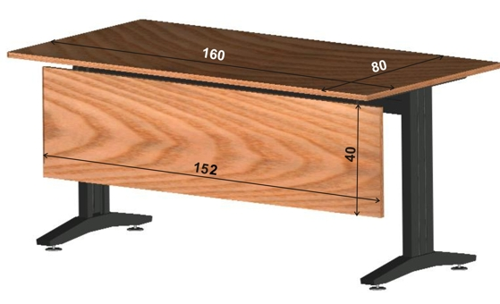
MILLENNIUM DESK
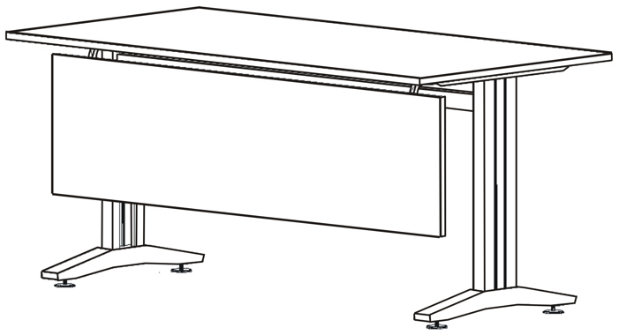
MILL-160*80

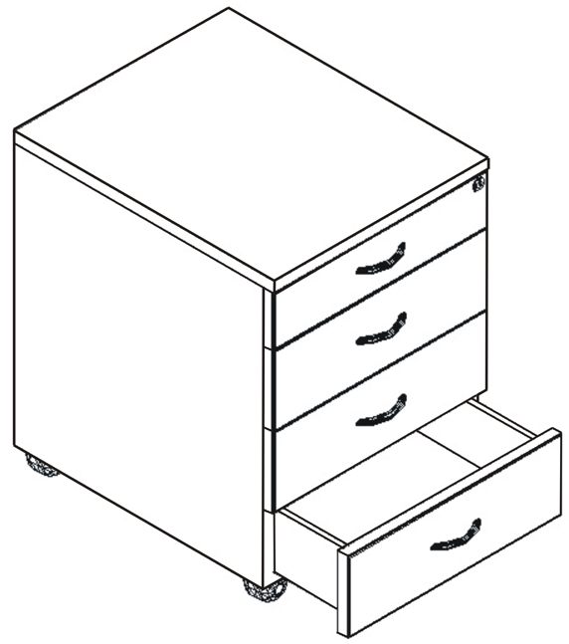
DFPANEL

WDR4

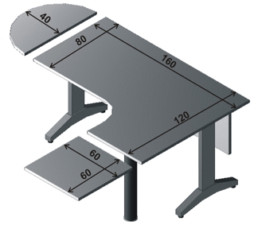
DEXT-80*40

Code | Description | Price
MILL-160*80  MILL-160*120  DFPANEL  DEXT-60*60  DEXT-80*40  WDR4 | Desk 160x80  Desk 160x80x120x60  Desk Front Panel 152x40  Desk Side Extension 60x60  Desk Semi Round Side Extension 80x40  Wooden Desk 4 Drawer Unit | €250.00+VAT (=€292.50)  €320.00+VAT (=€374.40)  €65.00+VAT (=€76.05)  €90.00+VAT (=€105.30)  €65.00+VAT (=€76.05)  €195.00+VAT (=€228.15)

MILL-160*120

DEXT-60*60

O/F 01

Ref. V052

OFFICE FURNITURE, MOBILE SYSTEMS, STORAGE SYSTEMS, SHELVING SYSTEMS, SAFES & VAULTS

