
NICOSIA HEAD OFFICE
P.O.Box 21212, 1504 Nicosia. Cyprus
Tel: +357-22354744, Fax: +357-22354932
LIMASSOL OFFICE
Tel: +357-25589913, Fax: +357-25586407
e-mail: viometal@logosnet.cy.net
web: www.viometal.net
VIOMETAL LTD
A. V a r n a v i d e s
Manufacturing & Engineering

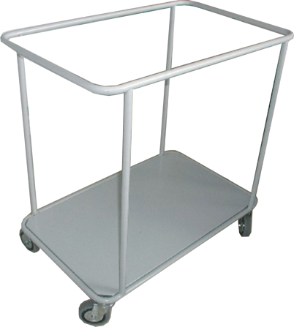
LINEN TROLLEY
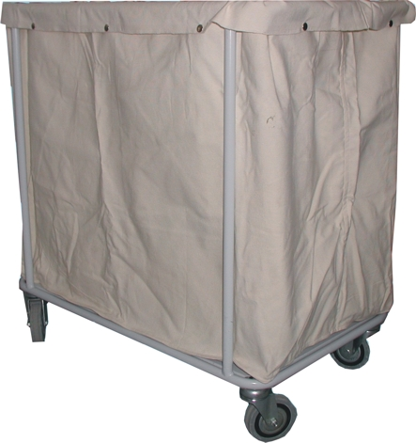

Linen Trolley Painted with 1 Bag(40)
Code: TRLINEN/P
Price: €260.00+VAT (=€304.20)
Additional Bag for Linen Trolley
Code: TRBAGLINEN
Price: €95.00+VAT (=€111.15)

OTHER 02

Ref. V051

OFFICE FURNITURE, MOBILE SYSTEMS, STORAGE SYSTEMS, SHELVING SYSTEMS, SAFES & VAULTS

