
NICOSIA HEAD OFFICE
P.O.Box 21212, 1504 Nicosia. Cyprus
Tel: +357-22354744, Fax: +357-22354932
LIMASSOL OFFICE
Tel: +357-25589913, Fax: +357-25586407
e-mail: viometal@logosnet.cy.net
web: www.viometal.net
VIOMETAL LTD
A. V a r n a v i d e s
Manufacturing & Engineering

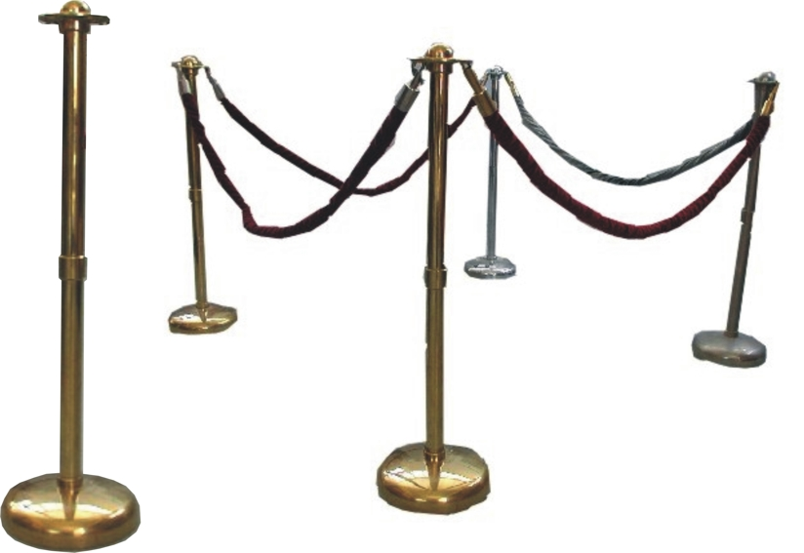
ROBE STAND

Robe Stand for Crowd Control
Code: ROBST
Dimensions: Ø35 x 100H
Price: €85.00+VAT (=€99.45).
Elegant Robe
Code; ROBE
Price: €40.00+VAT (=€46.80)

Ref. V050
OTHER 10

OFFICE FURNITURE, MOBILE SYSTEMS, STORAGE SYSTEMS, SHELVING SYSTEMS, SAFES & VAULTS

