
NICOSIA HEAD OFFICE
P.O.Box 21212, 1504 Nicosia. Cyprus
Tel: +357-22354744, Fax: +357-22354932
LIMASSOL OFFICE
Tel: +357-25589913, Fax: +357-25586407
e-mail: viometal@logosnet.cy.net
web: www.viometal.net
VIOMETAL LTD
A. V a r n a v i d e s
Manufacturing & Engineering

MIXTO POST
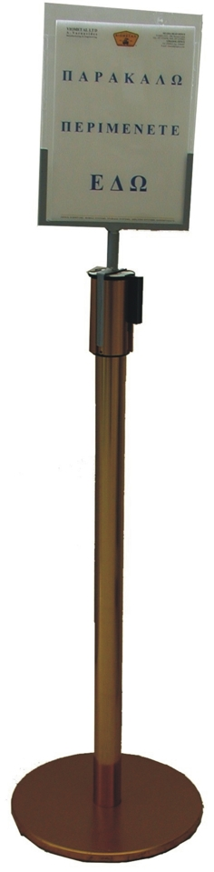
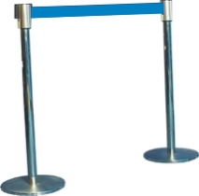

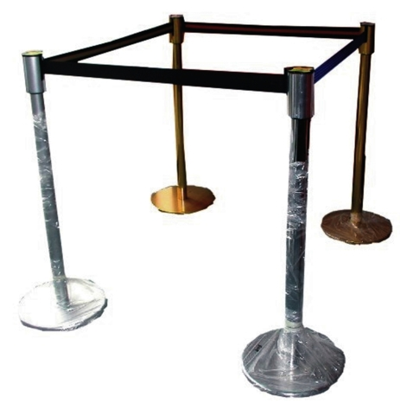

Mixto Post with Belt
Code: MIXTO
Dimensions: Ø35 x 100H (200cm)
Price: €95.00 + VAT (=€111.15)
Mixto Sign & Sign Holder
Code: MIXTO/SH
Price: €45.00+VAT (=€52.65)

Ref. V049
OTHER 09

OFFICE FURNITURE, MOBILE SYSTEMS, STORAGE SYSTEMS, SHELVING SYSTEMS, SAFES & VAULTS

