
NICOSIA HEAD OFFICE
P.O.Box 21212, 1504 Nicosia. Cyprus
Tel: +357-22354744, Fax: +357-22354932
LIMASSOL OFFICE
Tel: +357-25589913, Fax: +357-25586407
e-mail: viometal@logosnet.cy.net
web: www.viometal.net
VIOMETAL LTD
A. V a r n a v i d e s
Manufacturing & Engineering

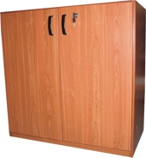
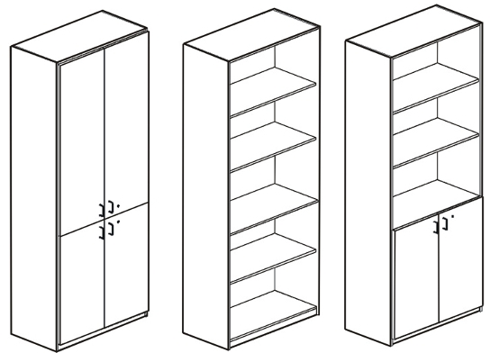
WOODEN BOOKCASES

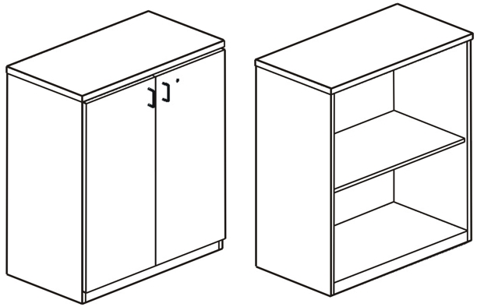
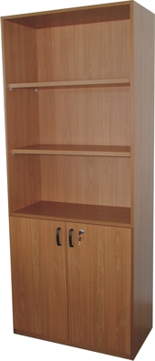

CODE | DESCRIPTION | DIMENSIONS | PRICE
WB197/4D | Wooden Bookcase With Four Doors | 80W X 38D X 197H | €400.00 + VAT(=€468.00)
WB197/P | Wooden Bookcase Open | 80W X 38D X 197H | €260.00 + VAT(=€304.20)
WB197/2BD | Wooden Bookcase With 2 Bottom Doors | 80W X 38D X 197H | €320.00 +VAT(=€374.40)
WB197/2G2D | Wooden Bookcase With Top Glass Doors and Bottom Wooden Doors | 80W X 38D X 197H | €450.00 +VAT(=€526.50)
WB90/2D | Wooden Bookcase With Doors | 80W X 38D X 90H | €265.00 + VAT(=€310.05)
WB90/P | Wooden Bookcase Open | 80W X 38D X 90H | €205.00 +VAT(=€239.85)

O/F 07

Ref. V048

OFFICE FURNITURE, MOBILE SYSTEMS, STORAGE SYSTEMS, SHELVING SYSTEMS, SAFES & VAULTS

