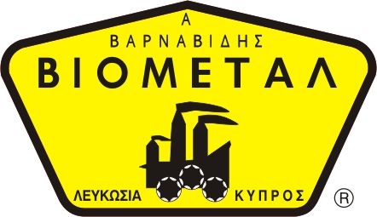
NICOSIA HEAD OFFICE
P.O.Box 21212, 1504 Nicosia. Cyprus
Tel: +357-22354744, Fax: +357-22354932
LIMASSOL OFFICE
Tel: +357-25589913, Fax: +357-25586407
e-mail: viometal@logosnet.cy.net
web: www.viometal.net
VIOMETAL LTD
A. V a r n a v i d e s
Manufacturing & Engineering

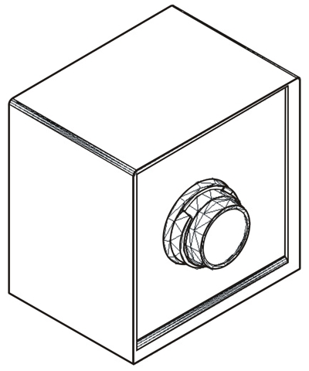
SAFETY KEY BOX
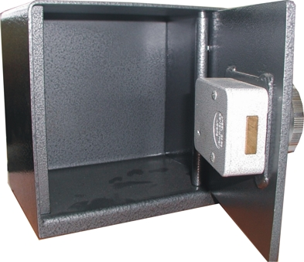

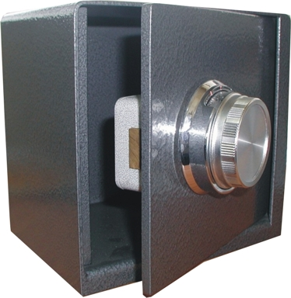

Code: SKB
Dimensions: 20W x 15D x 20H
Body thk. 3mm, Door thk. 6mm
With Dial Combination Lock
Price: €195.00+VAT (=€228.15)

Ref. V047
SAFES 22

OFFICE FURNITURE, MOBILE SYSTEMS, STORAGE SYSTEMS, SHELVING SYSTEMS, SAFES & VAULTS

