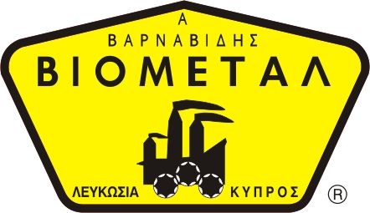
NICOSIA HEAD OFFICE
P.O.Box 21212, 1504 Nicosia. Cyprus
Tel: +357-22354744, Fax: +357-22354932
LIMASSOL OFFICE
Tel: +357-25589913, Fax: +357-25586407
e-mail: viometal@logosnet.cy.net
web: www.viometal.net
VIOMETAL LTD
A. V a r n a v i d e s
Manufacturing & Engineering

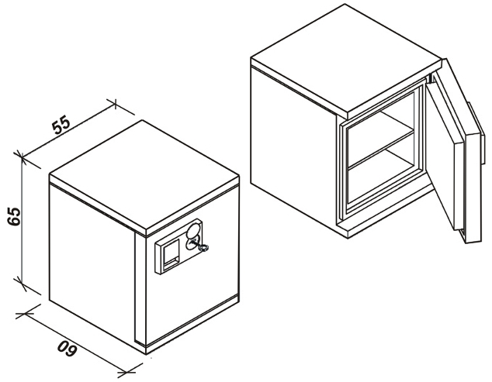

Data & Media Safe - 1 Hour Protection
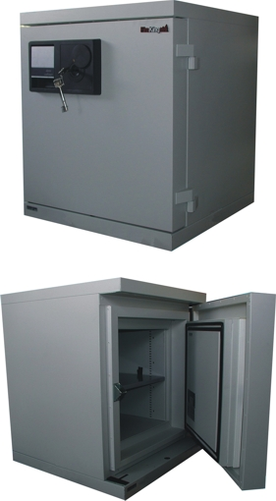

Code: DS1513-1LG
Dimensions (External) 55 x 60 x 65
Dimensions (Internal) 27 x 21 x 23
Price: €1500.00+VAT (=€1755.00)

Ref. V046
SAFES 15

OFFICE FURNITURE, MOBILE SYSTEMS, STORAGE SYSTEMS, SHELVING SYSTEMS, SAFES & VAULTS

