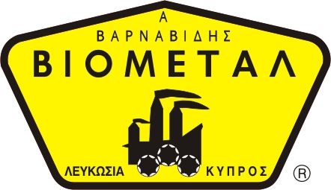
NICOSIA HEAD OFFICE
P.O.Box 21212, 1504 Nicosia. Cyprus
Tel: +357-22354744, Fax: +357-22354932
LIMASSOL OFFICE
Tel: +357-25589913, Fax: +357-25586407
e-mail: viometal@logosnet.cy.net
web: www.viometal.net
VIOMETAL LTD
A. V a r n a v i d e s
Manufacturing & Engineering


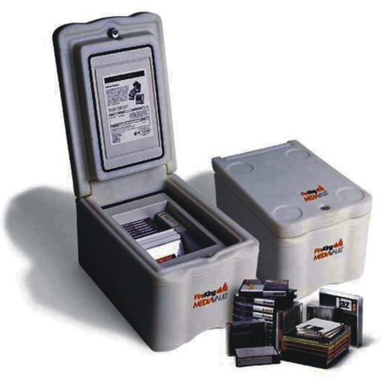

Media Vault
MV1000
The MediaVaultTM is ideal for small businesses and individuals that want to safeguard valuable computer media. It is the only media safe of its size to receive Underwriters' Laboratories Class 125, one-hour fire resistance rating for insulated record protection equipment.

The MediaVaultTM can be used as a stand-alone container or stored in a file cabinet of safe. If unit is stored in a file cabinet drawer, use bottom drawer only. Drawer suspension must have a minimum track capacity of 100 lbs./45kg.

Model | Description | Storage Capacity
MV1000 | MediaVault | 130 3-1/2” Diskettes  60 4mm DAT, 32 DC 2000/2120  30 8mm DAT, 23 Travan, 23 CDs  9 3480/3590, 31 Zip 100,*12 DLT  *(without plastic sleeves)
MV2006243015
MFG:243-2006

Dimensions
Outside:  Height  Width  Depth | 10-1/2”  11-5/8”  17-1/2”
Inside:  Height  Width  Depth | 5-7/8”  6-1/4”  8-7/8”
Weight: | 74lbs.
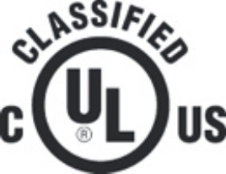

Record Protection Equipment
No.AV-19865
As to Fire-Resistance
Rating: Class 52-1HR Canada
Rating: Class 125-2HR U.S.A.
R-3691

Price: €450.00+VAT (=€526.50)

Ref. V045
SAFES 25

OFFICE FURNITURE, MOBILE SYSTEMS, STORAGE SYSTEMS, SHELVING SYSTEMS, SAFES & VAULTS

