
F&D 13
NICOSIA HEAD OFFICE
P.O.Box 21212, 1504 Nicosia. Cyprus
Tel: +357-22354744, Fax: +357-22354932
LIMASSOL OFFICE
Tel: +357-25589913, Fax: +357-25586407
e-mail: viometal@logosnet.cy.net
web: www.viometal.net
VIOMETAL LTD
A. V a r n a v i d e s
Manufacturing & Engineering

PLAT FILE STAND
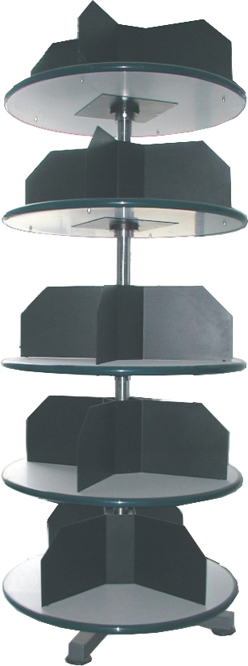
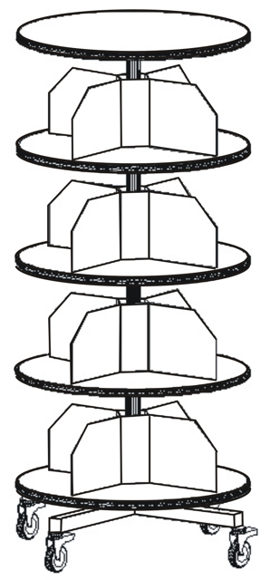

DESCRIPTION

- Code: PFS128
- DIM : D85 x 200H
- CAPACITY : 128 BOX FILES
- MOBILE
- SPACE-SAVING
- VERSATILE
- PRICE : € 765.00 + VAT (=€895.05)

Ref. V041

OFFICE FURNITURE, MOBILE SYSTEMS, STORAGE SYSTEMS, SHELVING SYSTEMS, SAFES & VAULTS

