
NICOSIA HEAD OFFICE
P.O.Box 21212, 1504 Nicosia. Cyprus
Tel: +357-22354744, Fax: +357-22354932
LIMASSOL OFFICE
Tel: +357-25589913, Fax: +357-25586407
e-mail: viometal@logosnet.cy.net
web: www.viometal.net
VIOMETAL LTD
A. V a r n a v i d e s
Manufacturing & Engineering

CHAMBERMAID TROLLEY (FOLDING)

Ref. V040
OTHER 01

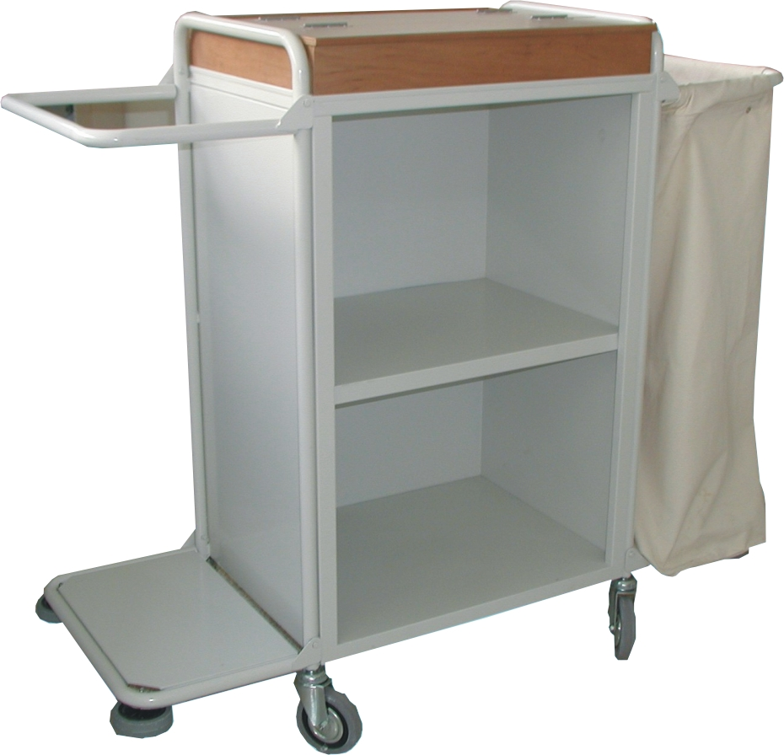

Dimensions in folded position : 77W x 54D x 142H
Dimensions in open position : 134W x 54D x 118H
CLOSED ON 3 SIDES IN 3 SHELVES
PROTECTIVE WHEELS ON CORNER EDGES
2 HEAVY DUTY CANVAS BAGS

Painted
Code: TRCHAMB/P Price : €520.00 + VAT (=€608.40)

ADDITIONAL BAG
Code: TRBAGCHAMB Price : €60.00 + VAT (=€70.20)

OFFICE FURNITURE, MOBILE SYSTEMS, STORAGE SYSTEMS, SHELVING SYSTEMS, SAFES & VAULTS

