
NICOSIA HEAD OFFICE
P.O.Box 21212, 1504 Nicosia. Cyprus
Tel: +357-22354744, Fax: +357-22354932
LIMASSOL OFFICE
Tel: +357-25589913, Fax: +357-25586407
e-mail: viometal@logosnet.cy.net
web: www.viometal.net
VIOMETAL LTD
A. V a r n a v i d e s
Manufacturing & Engineering

HEAVY DUTY PLATFORM TROLLEY

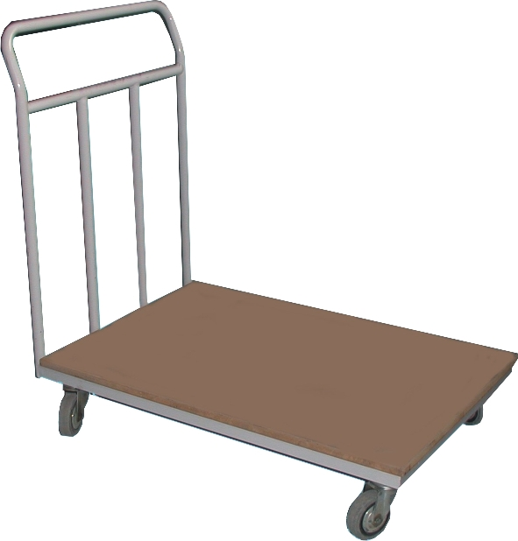

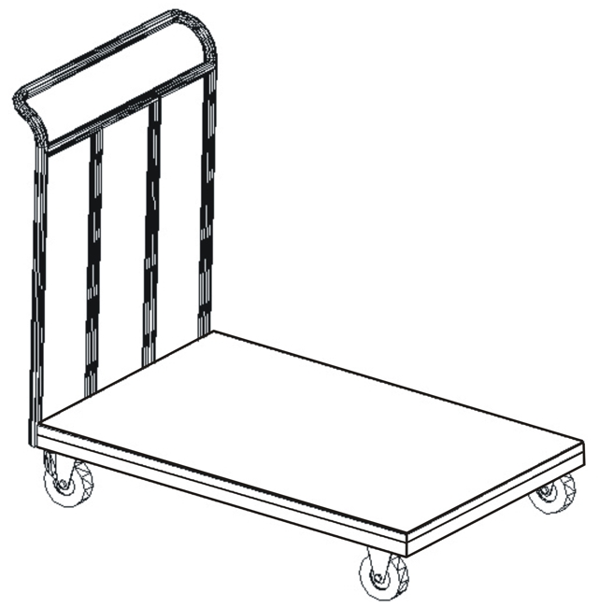

DESCRIPTION
Heavy Duty Platform Trolley
Code: TRPLAT/P

⬥ Platform Dimensions : 82 x 60 x 93H
⬥ 4 x 100mm Dia. Heavy Duty Castors
⬥ MDF 25mm Platform Floor
Price : €260.00 + VAT (=€304.20)

OTHER 03

Ref. V039

OFFICE FURNITURE, MOBILE SYSTEMS, STORAGE SYSTEMS, SHELVING SYSTEMS, SAFES & VAULTS

