
NICOSIA HEAD OFFICE
P.O.Box 21212, 1504 Nicosia. Cyprus
Tel: +357-22354744, Fax: +357-22354932
LIMASSOL OFFICE
Tel: +357-25589913, Fax: +357-25586407
e-mail: viometal@logosnet.cy.net
web: www.viometal.net
VIOMETAL LTD
A. V a r n a v i d e s
Manufacturing & Engineering

PLAN HANGER TROLLEY

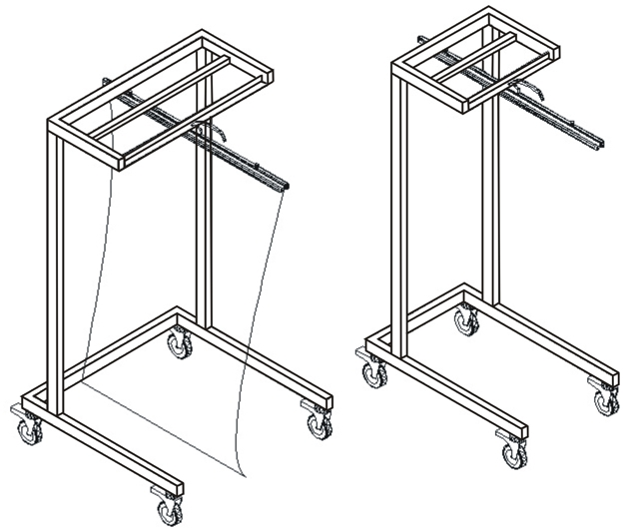
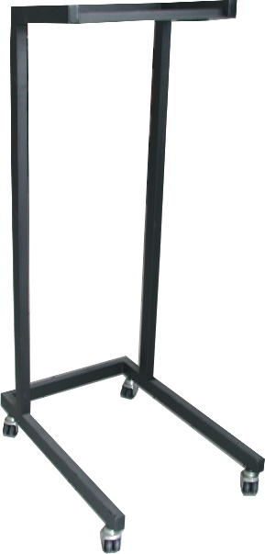

Description
- Mobile
- Space Saving
- Versatile
- Very Suitable for Projects/Site Office
- Most Popular Selling Model
- Number of Holding Clamps: 20/35
Small : 50W x 80D x 138H
Code : TRPLANH50 Price: €165.00+VAT (=€193.05)
Large : 80W x 80D x 138H
Code : TRPLANH80 Price: €180.00+VAT (=€210.60)
Holding Clamp
Code : PF600/1 Price: €25.00+VAT (=€29.25)
Box with 10 Pieces
Code: PF600BOX10 Price: €222.00+VAT (=€259.74)

Ref. V038
OTHER 04

OFFICE FURNITURE, MOBILE SYSTEMS, STORAGE SYSTEMS, SHELVING SYSTEMS, SAFES & VAULTS

