
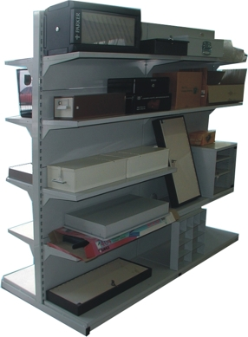
NICOSIA HEAD OFFICE
P.O.Box 21212, 1504 Nicosia. Cyprus
Tel: +357-22354744, Fax: +357-22354932
LIMASSOL OFFICE
Tel: +357-25589913, Fax: +357-25586407
e-mail: viometal@logosnet.cy.net
web: www.viometal.net
VIOMETAL LTD
A. V a r n a v i d e s
Manufacturing & Engineering

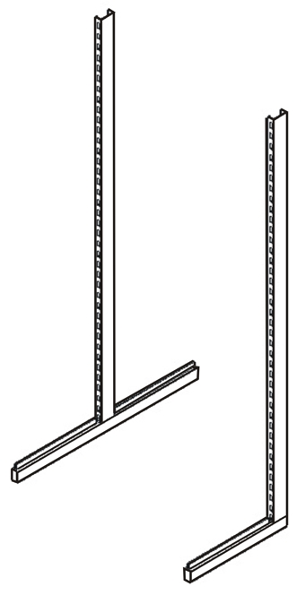
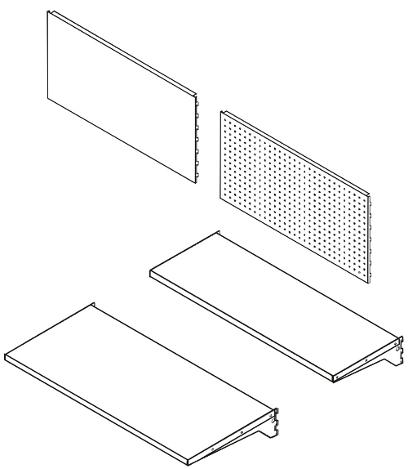
DISPLAY SHELVING
Back Panel
89x45 (Perforated)

Single side
Back Panel
89x45 (Plain)
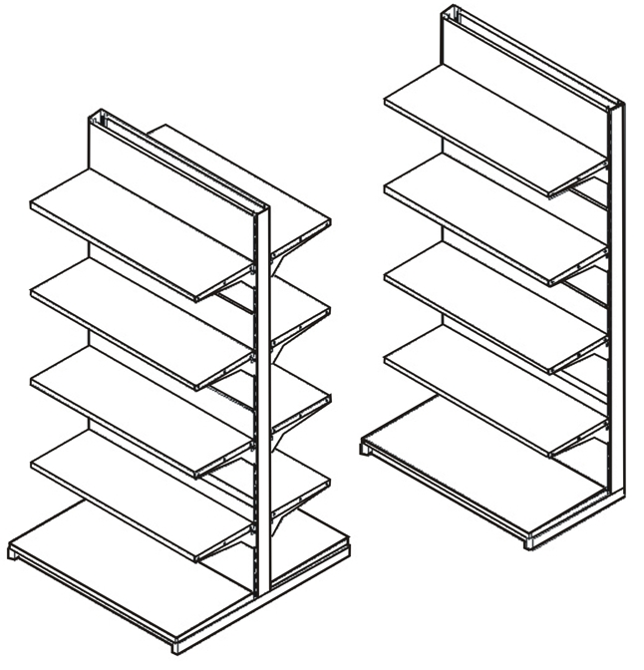

Code | Description | Price Each
DSUPL  DSUPT  DBPP  DBPH  DSH32  DSH42  DBSH42 | Display Support L  Display Support T  Display Back Panel (Plain)  Display Back Panel (Perforated)  Display Shelf 32 x 89 + Brackets  Display Shelf 42 x 89 + Brackets  Bottom Shelf 42 x 89 | €30.00+VAT (=€35.10)  €31.50+VAT (=€36.86)  €14.00+VAT (=€16.38)  €20.00+VAT (=€23.40)  €14.00+VAT (=€16.38)  €18.00+VAT (=€21.06)  €18.00+VAT (=€21.06)

Support - T

Shelf
32x89 + Brackets
Shelf
42x89 + Brackets
Support - L

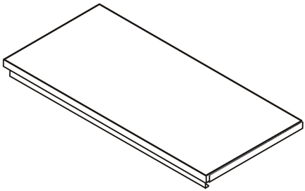

Double side
Bottom Shelf
42x89

Ref. V037
SH 01

OFFICE FURNITURE, MOBILE SYSTEMS, STORAGE SYSTEMS, SHELVING SYSTEMS, SAFES & VAULTS

