
NICOSIA HEAD OFFICE
P.O.Box 21212, 1504 Nicosia. Cyprus
Tel: +357-22354744, Fax: +357-22354932
LIMASSOL OFFICE
Tel: +357-25589913, Fax: +357-25586407
e-mail: viometal@logosnet.cy.net
web: www.viometal.net
VIOMETAL LTD
A. V a r n a v i d e s
Manufacturing & Engineering

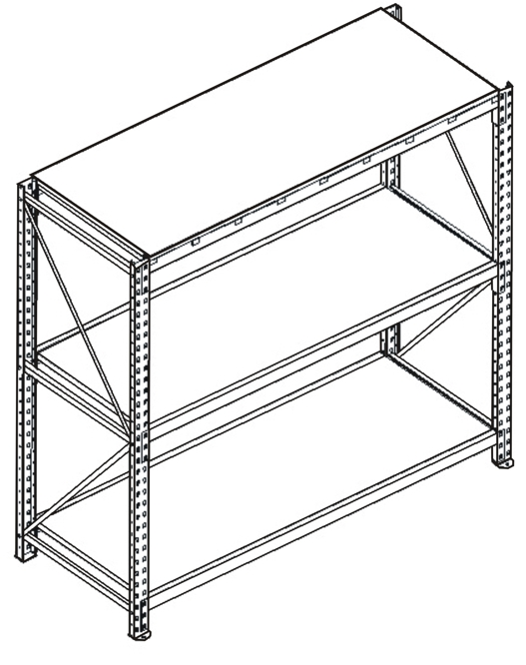

VIOMETAL HEAVY DUTY PALLET RACKIG SHELVES
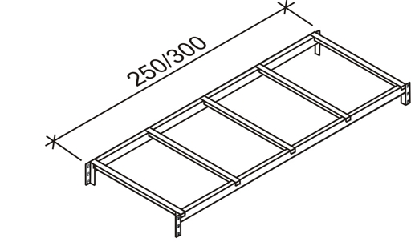
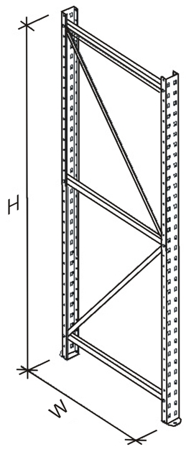
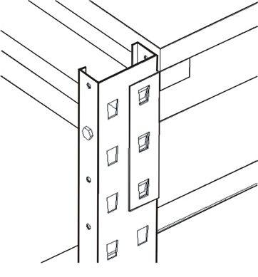

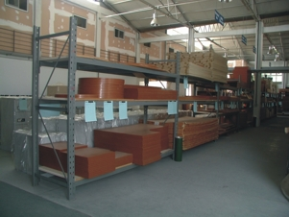

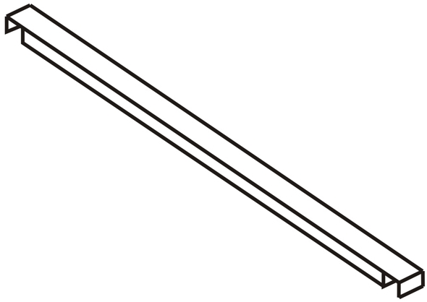

Heavy Duty

Corridor Connecting

Beam (HDC)

PAIRED

SUPPORT
Code | Description | Price
HDS200 | Heavy Duty Paired Support 90W x 200H | €67.00+VAT (=€78.39)
HDS250 | Heavy Duty Paired Support 90W x 250H | €75.00+VAT (=€87.75)
HDS300 | Heavy Duty Paired Support 90W x 300H | €82.00+VAT (=€95.94)
HDB250 | Heavy Duty Beam 250L | €30.00+VAT (=€35.10)
HDB300 | Heavy Duty Beam 300L | €33.00+VAT (=€38.61)
HDF250 | Wood or Metal Floor 90W x 250L | €67.00+VAT (=€78.39)
HDF300 | Wood or Metal Floor 90W x 300L | €78.00+VAT (=€91.26)
HDC | Heavy Duty Corridor Connecting Beam 90L | €10.00+VAT (=€11.70)

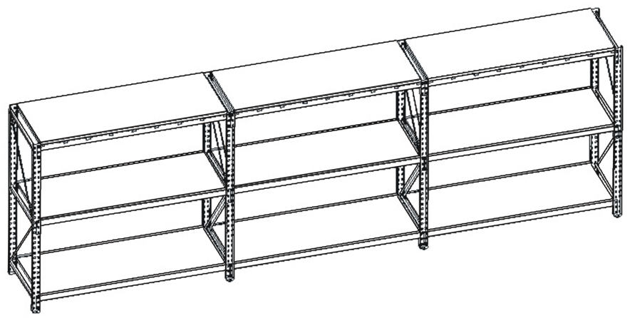

Ref. V036
SH 04

OFFICE FURNITURE, MOBILE SYSTEMS, STORAGE SYSTEMS, SHELVING SYSTEMS, SAFES & VAULTS

