
NICOSIA HEAD OFFICE
P.O.Box 21212, 1504 Nicosia. Cyprus
Tel: +357-22354744, Fax: +357-22354932
LIMASSOL OFFICE
Tel: +357-25589913, Fax: +357-25586407
e-mail: viometal@logosnet.cy.net
web: www.viometal.net
VIOMETAL LTD
A. V a r n a v i d e s
Manufacturing & Engineering

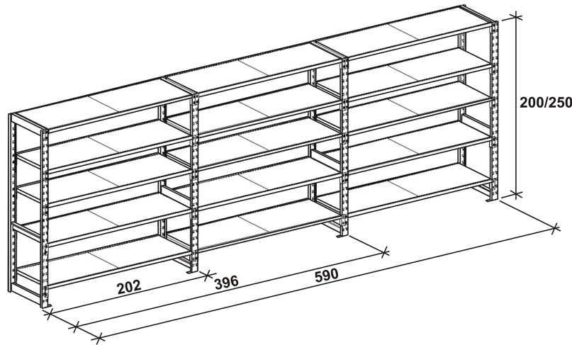
VIOMETAL MD FLEXIBLE SHELVES
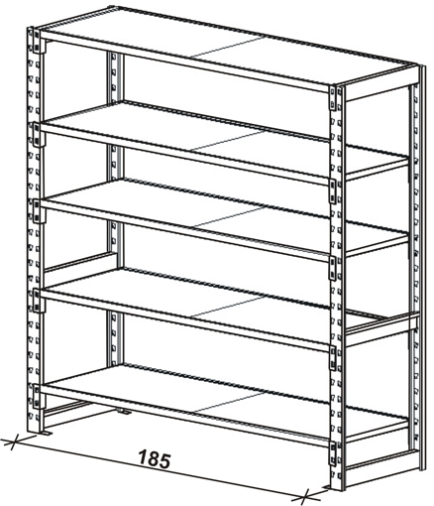

CODE  MDSU200-32  MDSU200-42  MDSU200-58  MDSU250-32  MDSU250-42  MDSU250-58  SHBF-32  SHBF-42  SHBF-58 | DESCRIPTION  Vertical Support (32W x 200H)  Vertical Support (42W x 200H)  Vertical Support (58W x 200H)  Vertical Support (32W x 250H)  Vertical Support (42W x 250H)  Vertical Support (58W x 250H)  Shelf Including Beams and Floor 185W x 32D  Shelf Including Beams and Floor 185W x 42D  Shelf Including Beams and Floor 185W x 58D | PRICE EACH  €62.00+VAT (=€72.54)  €62.00+VAT (=€72.54)  €62.00+VAT (=€72.54)  €67.00+VAT (=€78.39)  €67.00+VAT (=€78.39)  €67.00+VAT (=€78.39)  €62.00+VAT (=€72.54)  €65.00+VAT (=€76.05)  €71.00+VAT (=€83.07)
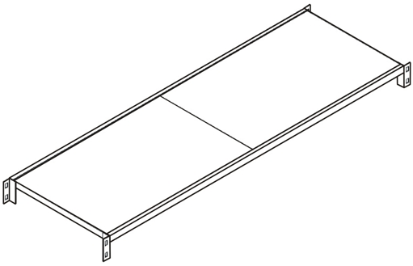
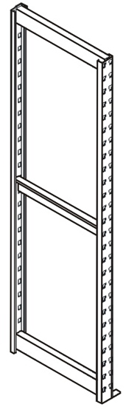

Vertical Support

Ref. V035
SH 03
Horizontal Shelving with Beams

OFFICE FURNITURE, MOBILE SYSTEMS, STORAGE SYSTEMS, SHELVING SYSTEMS, SAFES & VAULTS

