
NICOSIA HEAD OFFICE
P.O.Box 21212, 1504 Nicosia. Cyprus
Tel: +357-22354744, Fax: +357-22354932
LIMASSOL OFFICE
Tel: +357-25589913, Fax: +357-25586407
e-mail: viometal@logosnet.cy.net
web: www.viometal.net
VIOMETAL LTD
A. V a r n a v i d e s
Manufacturing & Engineering

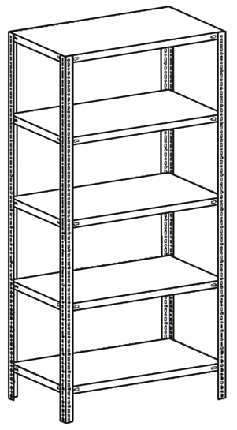
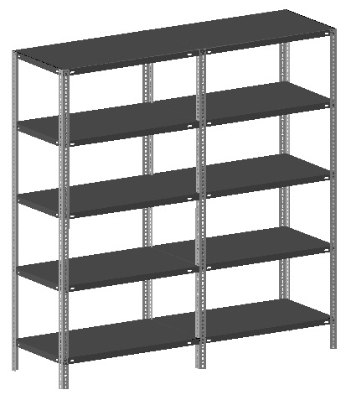
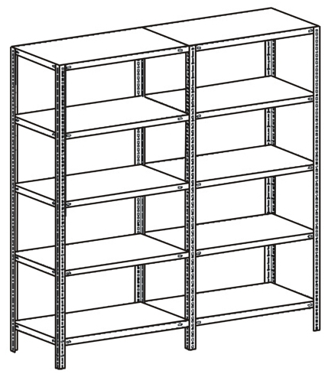
METAL SHELVES

Ref. V034

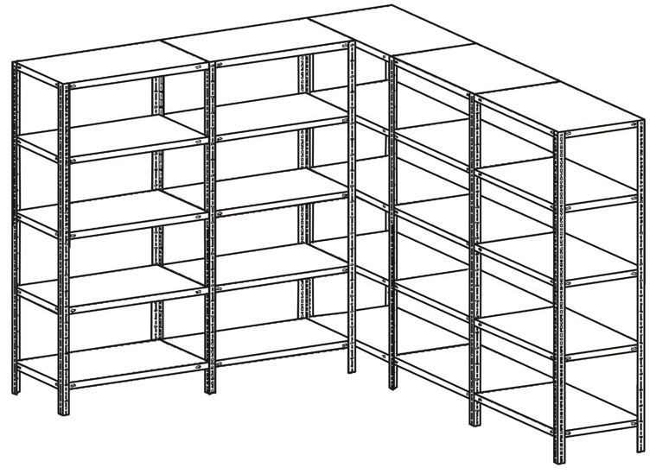

Code | Item | Without Installation | Including Delivery and Installation
SH32  SH42  SH58 | SHELVES  92 x 32cm  92 x 42cm  92 x 58cm | €7.00+VAT (=€8.19)  €9.00+VAT (=€10.53)  €11.60+VAT (=€13.57) | €9.60+VAT (=€11.23)  €11.60+VAT (=€13.57)  €14.20+VAT (=€16.61)
SUP6  SUP7  SUP8  SUP9  SUP10 | SUPPORT  6FT (183cm)  7FT (213cm)  8FT (244cm)  9FT (274cm)  10FT (305cm) | €8.00+VAT (=€9.36)  €8.50+VAT (=€9.95)  €9.50+VAT (=€11.12)  €10.50+VAT (=€12.29)  €11.50+VAT (=€13.46) | €8.00+VAT (=€9.36)  €8.50+VAT (=€9.95)  €9.50+VAT (=€11.12)  €10.50+VAT (=€12.29)  €11.50+VAT (=€13.46)

**Bolts & Nuts (1Set) Code: 14100
=0.09+VAT (=0.11) Cents (Each Set)

\
SH 02
OFFICE FURNITURE, MOBILE SYSTEMS, STORAGE SYSTEMS, SHELVING SYSTEMS, SAFES & VAULTS

