
NICOSIA HEAD OFFICE
P.O.Box 21212, 1504 Nicosia. Cyprus
Tel: +357-22354744, Fax: +357-22354932
LIMASSOL OFFICE
Tel: +357-25589913, Fax: +357-25586407
e-mail: viometal@logosnet.cy.net
web: www.viometal.net
VIOMETAL LTD
A. V a r n a v i d e s
Manufacturing & Engineering

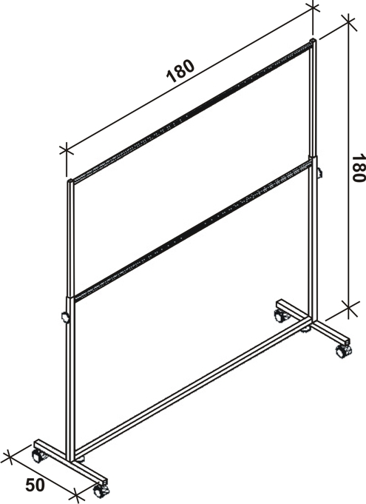
Hanging Rail
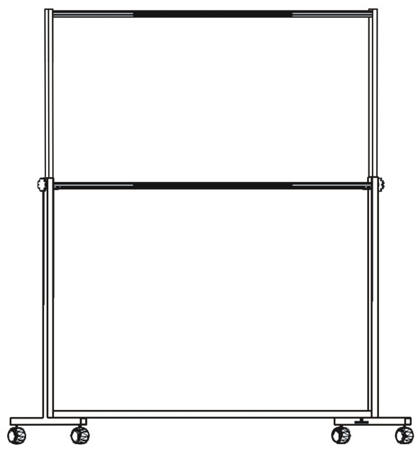

Code: HANGING RAIL
Dimensions: 180 x 180 x 50
Price: €195.00 + VAT (=€228.15)

Ref. V033
OTHER 06

OFFICE FURNITURE, MOBILE SYSTEMS, STORAGE SYSTEMS, SHELVING SYSTEMS, SAFES & VAULTS

