
NICOSIA HEAD OFFICE
P.O.Box 21212, 1504 Nicosia. Cyprus
Tel: +357-22354744, Fax: +357-22354932
LIMASSOL OFFICE
Tel: +357-25589913, Fax: +357-25586407
e-mail: viometal@logosnet.cy.net
web: www.viometal.net
VIOMETAL LTD
A. V a r n a v i d e s
Manufacturing & Engineering

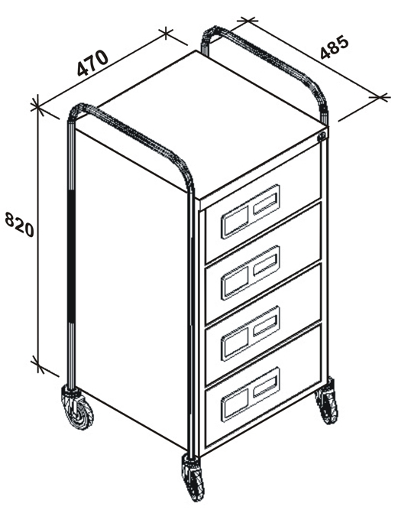

MOBILE DRAWER UNIT
For General Storage

Ref. V032
OTHER 07
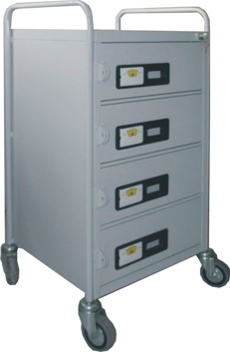

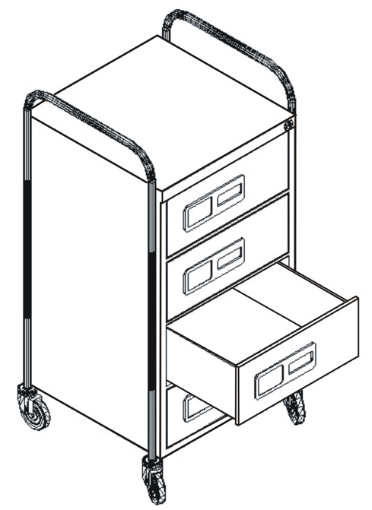

Code: MDU4/B
Drawer Unit Dimensions: 47W x 48D x 82H
Total Dimensions: 51W x 48D x 106H
4 Drawers
Price: €450.00+VAT (=€526.50)

OFFICE FURNITURE, MOBILE SYSTEMS, STORAGE SYSTEMS, SHELVING SYSTEMS, SAFES & VAULTS

