
NICOSIA HEAD OFFICE
P.O.Box 21212, 1504 Nicosia. Cyprus
Tel: +357-22354744, Fax: +357-22354932
LIMASSOL OFFICE
Tel: +357-25589913, Fax: +357-25586407
Email: Viometal@logosnet.cy.net
Web: www.viometal.net
VIOMETAL LTD
A. V a r n a v i d e s
Manufacturing & Engineering

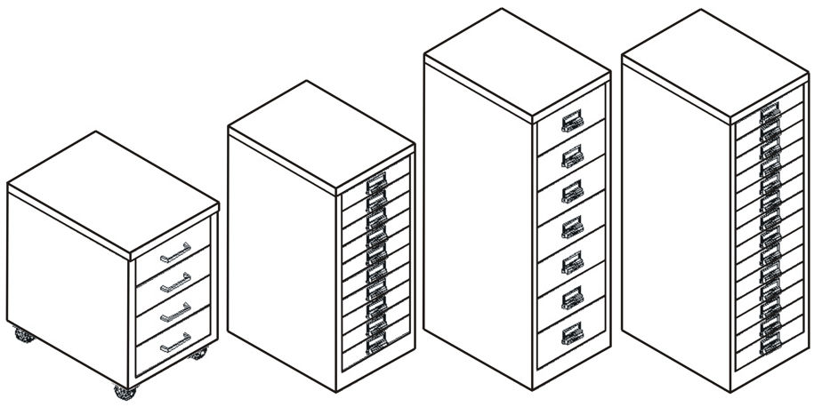
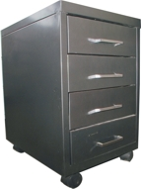
MULTIDRAWER CABINETS
DRU7
DRU14

DRU10

DRU4

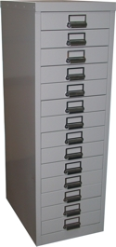

CODE | DESCRIPTION | DIMENSIONS | PRICE
DRU4 | 4 DRAWERS METAL  with Castors | 38W x 55D x 55H | €160.00+VAT (=€187.20)
DRU7 | 7 DRAWERS METAL | 32W x 46D x 100H | €280.00+VAT (=€327.60)
DRU10 | 10 DRAWERS METAL | 32W x 46D x 74H | €270.00+VAT (=€315.90)
DRU14 | 14 DRAWERS METAL | 32W x 46D x 100H | €320.00+VAT (=€374.40)

Ref. V031
F&D 17-20

OFFICE FURNITURE, MOBILE SYSTEMS, STORAGE SYSTEMS, SHELVING SYSTEMS, SAFES & VAULTS

