
NICOSIA HEAD OFFICE
P.O.Box 21212, 1504 Nicosia. Cyprus
Tel: +357-22354744, Fax: +357-22354932
LIMASSOL OFFICE
Tel: +357-25589913, Fax: +357-25586407
e-mail: viometal@logosnet.cy.net
web: www.viometal.net
VIOMETAL LTD
A. V a r n a v i d e s
Manufacturing & Engineering

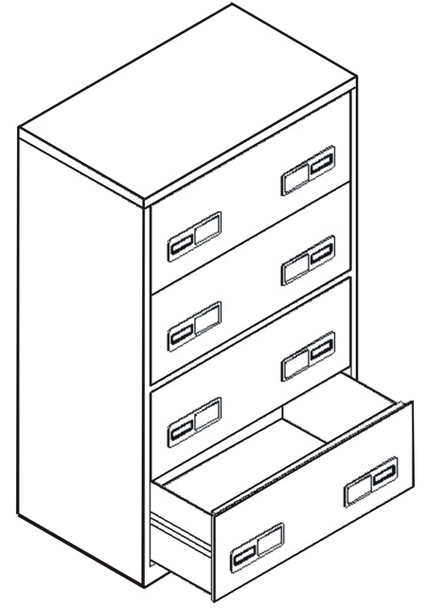
WIDE FILING CABINETS
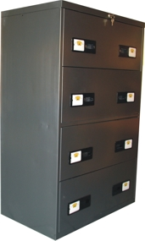

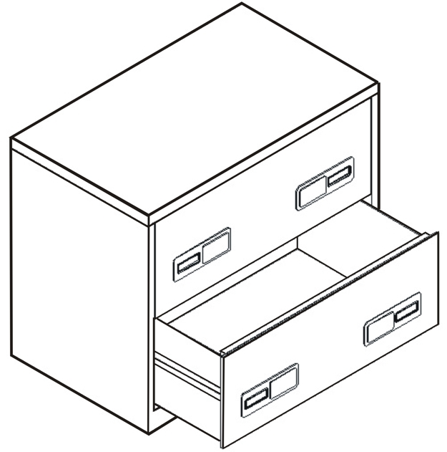

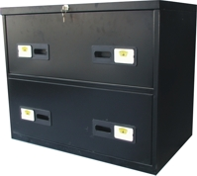

F&D 05,06
CODE | DESCRIPTION | DIMENSIONS | PRICE
FC2/W | WIDE FILING CABINETS WITH 2 DRAWERS AND ADJUSTABLE HANGERS GRID | 85W x 50D x 72H | €350.00+VAT (=€409.50)
FC4/W | WIDE FILING CABINETS WITH 4 DRAWERS AND ADJUSTABLE HANGERS GRID | 85W x 50D x 134H | €450.00+VAT (=€526.50)

Ref. V030

OFFICE FURNITURE, MOBILE SYSTEMS, STORAGE SYSTEMS, SHELVING SYSTEMS, SAFES & VAULTS

