
F&D 07-12
NICOSIA HEAD OFFICE
P.O.Box 21212, 1504 Nicosia. Cyprus
Tel: +357-22354744, Fax: +357-22354932
LIMASSOL OFFICE
Tel: +357-25589913, Fax: +357-25586407
e-mail: viometal@logosnet.cy.net
web: www.viometal.net
VIOMETAL LTD
A. V a r n a v i d e s
Manufacturing & Engineering

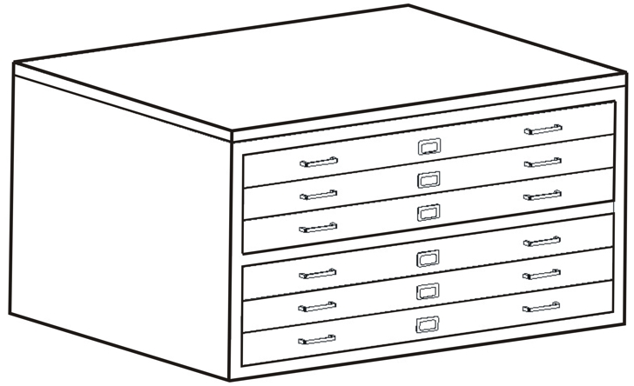
A0 – 6 Drawers
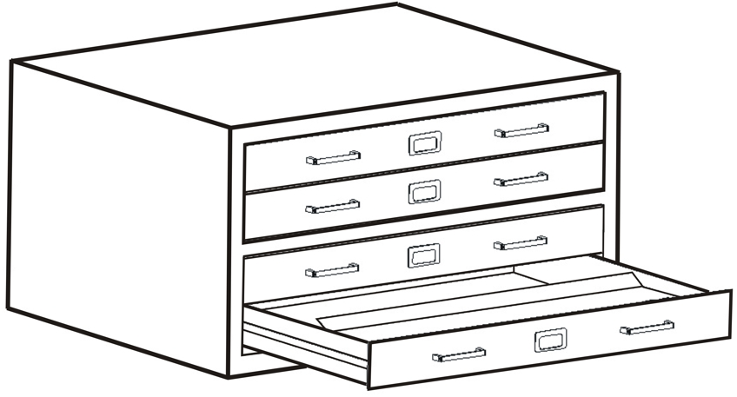
A1 – 4 Drawers
PLAN CABINETS

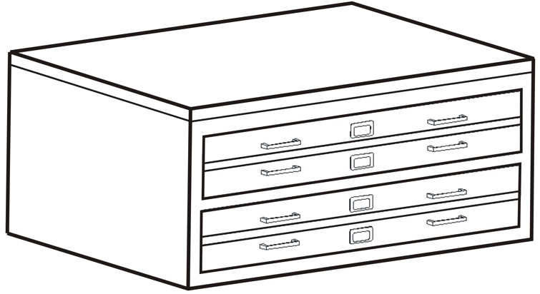
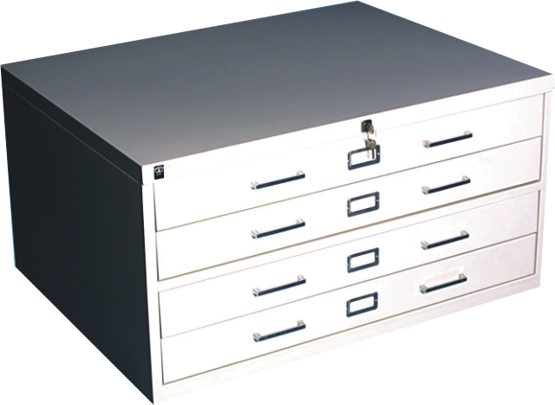
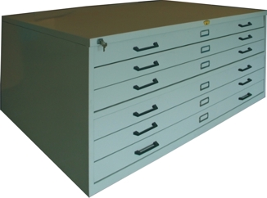
B1 – 4 Drawers

CODE | DESCRIPTION | DIMENSIONS | PAPER SIZE | PRICE
PFCA1-4  PFCA1-6  PFCB1-4  PFCB1-6  PFCA0-4  PFCA0-6 | 4 DRAWERS FOR A1 PAPER SIZE  6 DRAWERS FOR A1 PAPER SIZE  4 DRAWERS FOR B1 PAPER SIZE  6 DRAWERS FOR B1 PAPER SIZE  4 DRAWERS FOR A0 PAPER SIZE  6 DRAWERS FOR A0 PAPER SIZE  ** CENTRAL LOCK PAPER HOLD DOWN FLAP | 94W x 74D x 50H  94W x 74D x 70H  115W x 84D x 50H  115W x 84D x 70H  133W x 95D x 50H  133W x 95D x 70H | 86W x 65D  86W x 65D  105W x 78D  105W x 78D  118W x 84D  118W x 84D | €480.00+VAT (=€561.60)  €615.00+VAT (=€719.55)  €530.00+VAT (=€620.10)  €700.00+VAT (=€819.00)  €750.00+VAT (=€877.50)  €955.00+VAT (=€1,117.35)  Ref. V029

OFFICE FURNITURE, MOBILE SYSTEMS, STORAGE SYSTEMS, SHELVING SYSTEMS, SAFES & VAULTS

