
NICOSIA HEAD OFFICE
P.O.Box 21212, 1504 Nicosia. Cyprus
Tel: +357-22354744, Fax: +357-22354932
LIMASSOL OFFICE
Tel: +357-25589913, Fax: +357-25586407
e-mail: viometal@logosnet.cy.net
web: www.viometal.net
VIOMETAL LTD
A. V a r n a v i d e s
Manufacturing & Engineering

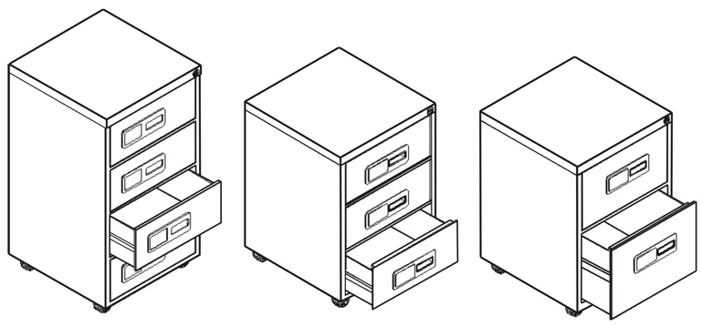
METAL DRAWER UNITS

** Metal Drawer Units on Castors with:
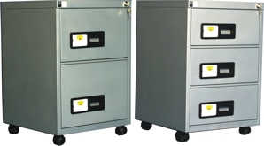
Code | Description | Dimensions | Price
MDU2 | 2 Drawers: One Ordinary and One  Filing Drawer | 47W x 48D x 63H | €240.00+VAT (=€280.80)
MDU3 | 3 Drawers | 47W x 48D x 63H | €270.00+VAT (=€315.90)
MDU4 | 4 Drawers | 47W x 48D x 82H | €300.00+VAT (=€351.00)

Ref. V028
F&D 14-16
OFFICE FURNITURE, MOBILE SYSTEMS, STORAGE SYSTEMS, SHELVING SYSTEMS, SAFES & VAULTS

