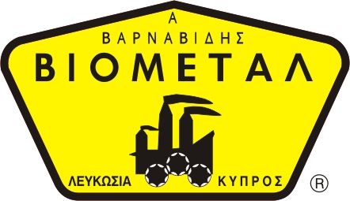
NICOSIA HEAD OFFICE
P.O.Box 21212, 1504 Nicosia. Cyprus
Tel: +357-22354744, Fax: +357-22354932
LIMASSOL OFFICE
Tel: +357-25589913, Fax: +357-25586407
e-mail: viometal@logosnet.cy.net
web: www.viometal.net
VIOMETAL LTD
A. V a r n a v i d e s
Manufacturing & Engineering

HOTEL ROOMSAFE 42x38x23H – SUPREME
(Quantity Sales Only for Hotels)

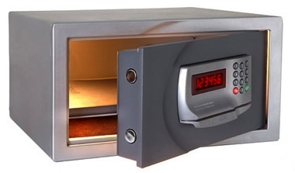

DESCRIPTION
Code: HRS 42x38x23H-SUPREME
Dimensions: 42W x 38D x 23H
Body Thickness: 2mm
Door Thickness: 6mm
Volume: 18L
Weight: 10.5kg
- High Security Electronic Lock
- Automatic inside light
- Illuminated key buttons
- Carpet on the base inside
Price: €160.00+VAT (=€187.20)

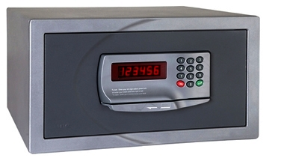

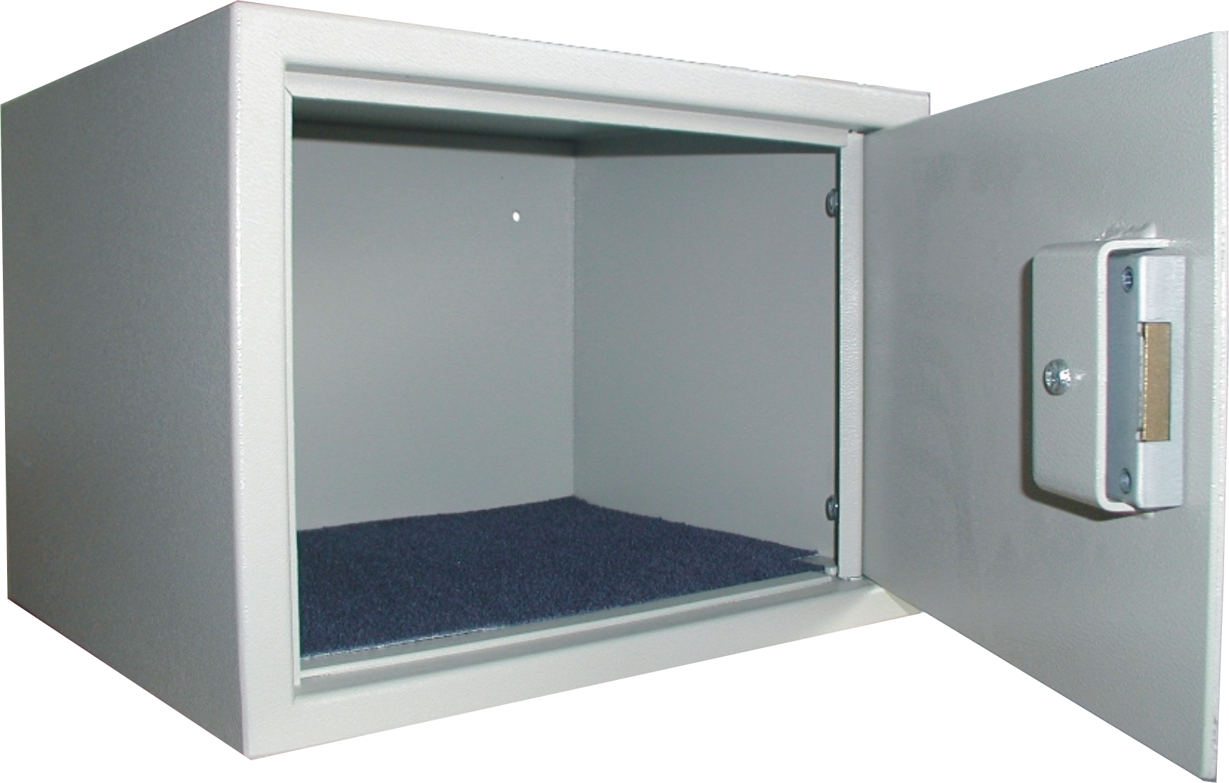

Ref. V026
SAFES 21

OFFICE FURNITURE, MOBILE SYSTEMS, STORAGE SYSTEMS, SHELVING SYSTEMS, SAFES & VAULTS

