
O/F 08
NICOSIA HEAD OFFICE
P.O.Box 21212, 1504 Nicosia. Cyprus
Tel: +357-22354744, Fax: +357-22354932
LIMASSOL OFFICE
Tel: +357-25589913, Fax: +357-25586407
e-mail: viometal@logosnet.cy.net
web: www.viometal.net
VIOMETAL LTD
A. V a r n a v i d e s
Manufacturing & Engineering

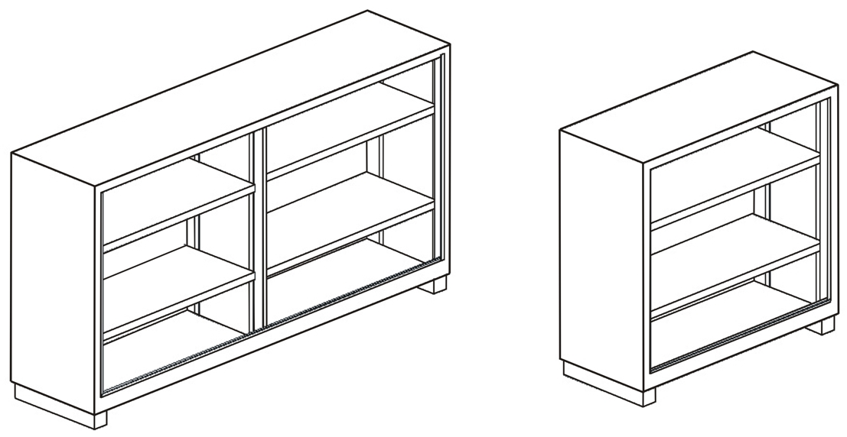
VIOMETAL BOOKCASES WITH SLIDING DOORS

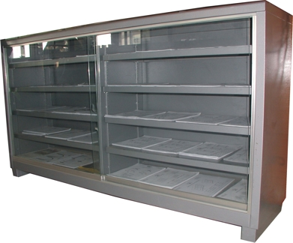

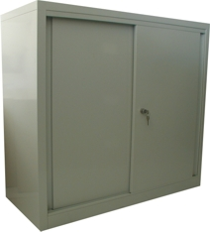

Ref. V023

CODE | DESCRIPTION | DIMENSIONS | PRICE
MB100  MB184  MB100/M  MB100/G  MB184/M  MB184/G | Metal Bookcase Open with 2 Adj. Shelves.  Metal Bookcase Open with 4 Adj. Shelves.  Metal Bookcases + Metal Doors & Adj. Shelves.  Metal Bookcases + Glass Doors & Adj. Shelves.  Metal Bookcases + Metal Doors & Adj. Shelves.  Metal Bookcases + Glass Doors & Adj. Shelves. | 100W X 38D X 100H  183W X 38D X 100H  100W X 38D X 100H  100W X 38D X 100H  183W X 38D X 100H  183W X 38D X 100H | €210.00 + VAT (=€245.70)  €320.00 + VAT (=€374.40)  €290.00 + VAT (=€339.30)  €330.00 + VAT (=€386.10)  €390.00 + VAT (=€456.30)  €450.00 + VAT (=€526.50)

OFFICE FURNITURE, MOBILE SYSTEMS, STORAGE SYSTEMS, SHELVING SYSTEMS, SAFES & VAULTS

