
NICOSIA HEAD OFFICE
P.O.Box 21212, 1504 Nicosia. Cyprus
Tel: +357-22354744, Fax: +357-22354932
LIMASSOL OFFICE
Tel: +357-25589913, Fax: +357-25586407
e-mail: viometal@logosnet.cy.net
web: www.viometal.net
VIOMETAL LTD
A. V a r n a v i d e s
Manufacturing & Engineering

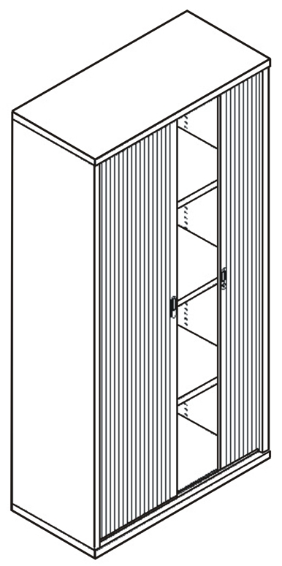
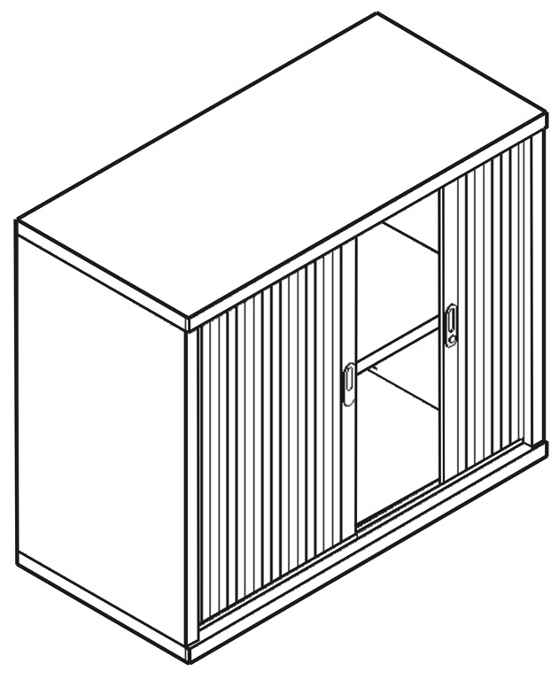
METAL CUPBOARD WITH TAMBOUR DOORS
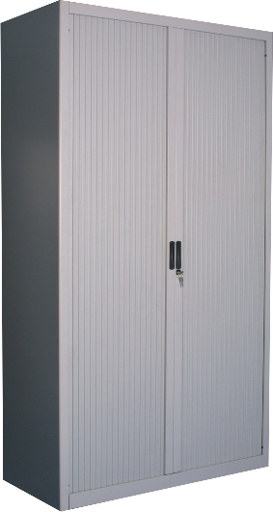

SPECIFICATION
* Tambour Door (Plastic) * Adjustable Shelves
* CAM Locking System

Code | Width in mm | Depth in mm | Height in mm | Shelves (Adj.) | Prices
MCTD85 | 1000 | 485 | 1000 | 1 | €410.00 + VAT (€479.70)
MCTD155 | 1000 | 485 | 1535 | 2 | €460.00 + VAT (€538.20)
MCTD200 | 1000 | 485 | 1985 | 3 | €510.00 + VAT (€596.70)

Ref. V022
OFFICE FURNITURE, MOBILE SYSTEMS, STORAGE SYSTEMS, SHELVING SYSTEMS, SAFES & VAULTS
L&C 05-07

