
L&C 10
NICOSIA HEAD OFFICE
P.O.Box 21212, 1504 Nicosia. Cyprus
Tel: +357-22354744, Fax: +357-22354932
LIMASSOL OFFICE
Tel: +357-25589913, Fax: +357-25586407
e-mail: viometal@logosnet.cy.net
web: www.viometal.net
VIOMETAL LTD
A. V a r n a v i d e s
Manufacturing & Engineering

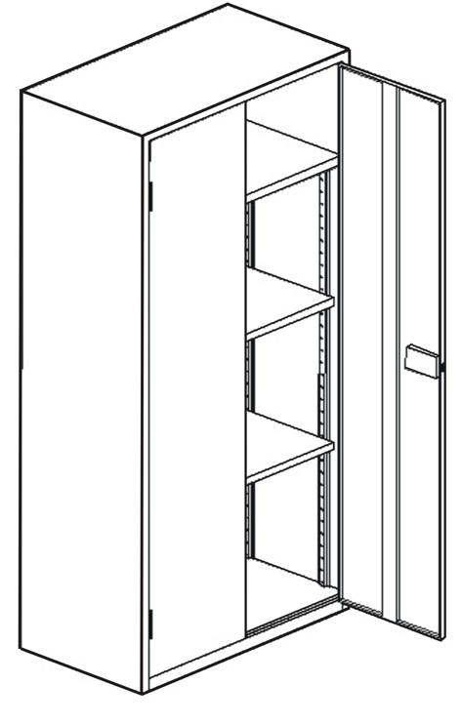
METAL CUPBOARD with Vertical Separation
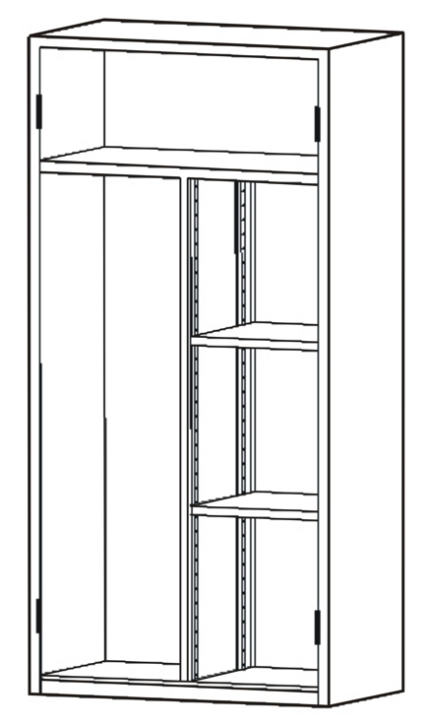
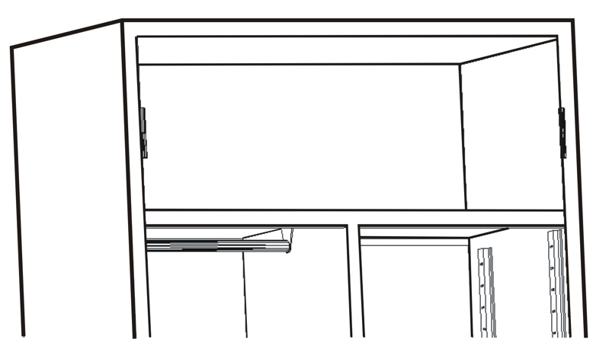

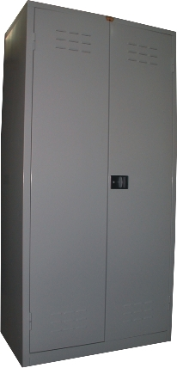
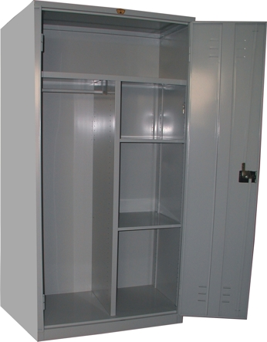

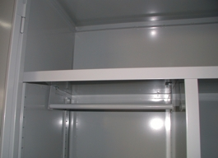

Code: MC183T
Dim: 91W x 49D x 183H
2 Height Adjustable Shelves
Price: €370.00 + VAT (€432.90)

Ref. V021

OFFICE FURNITURE, MOBILE SYSTEMS, STORAGE SYSTEMS, SHELVING SYSTEMS, SAFES & VAULTS

