
L&C 08,09
NICOSIA HEAD OFFICE
P.O.Box 21212, 1504 Nicosia. Cyprus
Tel: +357-22354744, Fax: +357-22354932
LIMASSOL OFFICE
Tel: +357-25589913, Fax: +357-25586407
e-mail: viometal@logosnet.cy.net
web: www.viometal.net
VIOMETAL LTD
A. V a r n a v i d e s
Manufacturing & Engineering

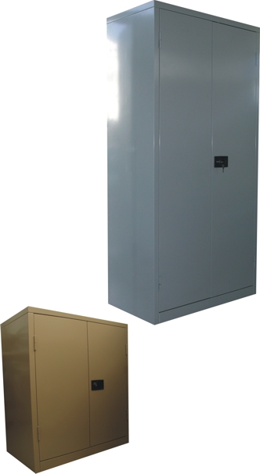
METAL CUPBOARDS
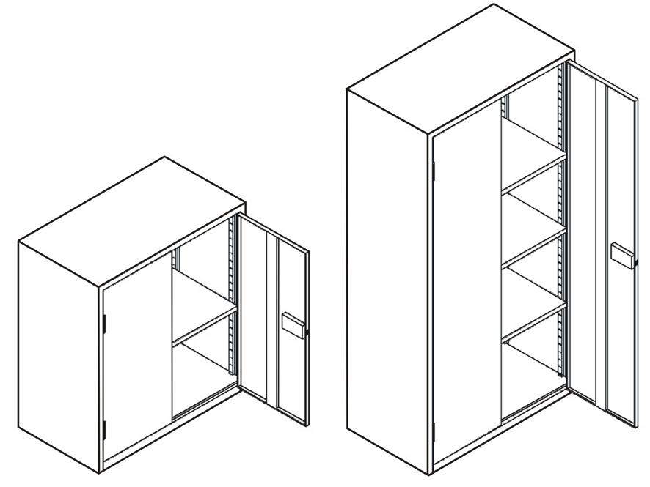

Code | Width in mm | Depth in mm | Height in mm | Shelves (adjustable) | Price
MC100 | 910 | 490 | 1000 | 1 | €250.00 + VAT (€292.50)
MC183 | 910 | 490 | 1830 | 3 | €320.00 + VAT (€374.40)

Ref. V020
OFFICE FURNITURE, MOBILE SYSTEMS, STORAGE SYSTEMS, SHELVING SYSTEMS, SAFES & VAULTS

