
L&C 04
NICOSIA HEAD OFFICE
P.O.Box 21212, 1504 Nicosia. Cyprus
Tel: +357-22354744, Fax: +357-22354932
LIMASSOL OFFICE
Tel: +357-25589913, Fax: +357-25586407
e-mail: viometal@logosnet.cy.net
web: www.viometal.net
VIOMETAL LTD
A. V a r n a v i d e s
Manufacturing & Engineering

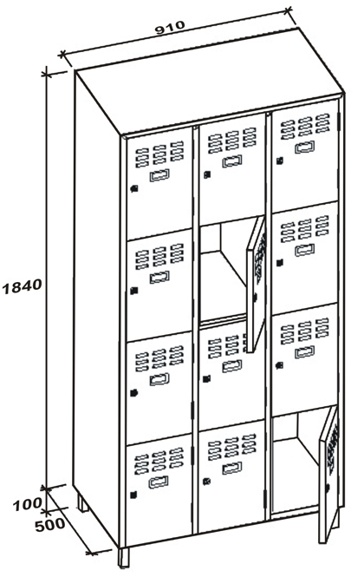
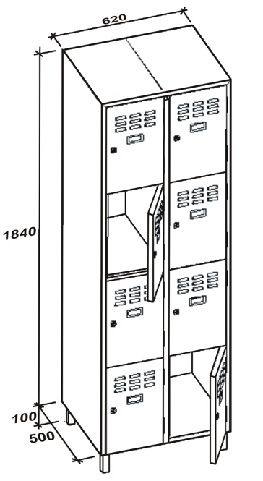
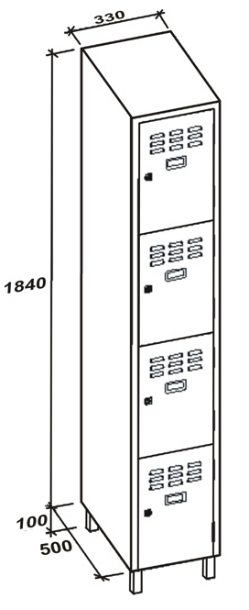
VIOMETAL 1/4 DOOR LOCKERS
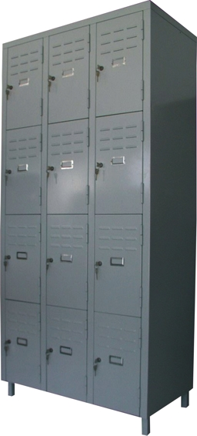

12FD
8FD
4FD

Code | Width in mm | Depth in mm | Height in mm | Description | Price
VL/4FD | 330 | 500 | 1940 | FOUR 1/4 DOORS | €285.00+VAT (=€333.45)
VL/8FD | 620 | 500 | 1940 | EIGHT 1/4 DOORS | €500.00+VAT (=€585.00)
VL/12FD | 910 | 500 | 1940 | TWELVE 1/4 DOORS | €685.00+VAT (=€801.45)

Ref. V019

OFFICE FURNITURE, MOBILE SYSTEMS, STORAGE SYSTEMS, SHELVING SYSTEMS, SAFES & VAULTS

