
L&C 03
NICOSIA HEAD OFFICE
P.O.Box 21212, 1504 Nicosia. Cyprus
Tel: +357-22354744, Fax: +357-22354932
LIMASSOL OFFICE
Tel: +357-25589913, Fax: +357-25586407
e-mail: viometal@logosnet.cy.net
web: www.viometal.net
VIOMETAL LTD
A. V a r n a v i d e s
Manufacturing & Engineering

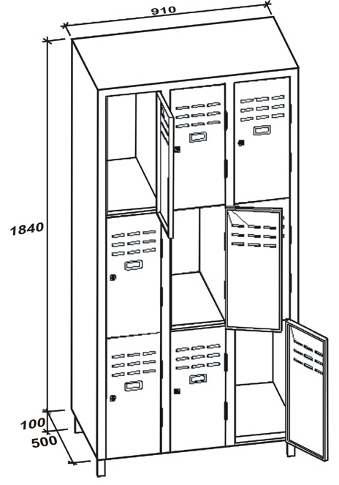
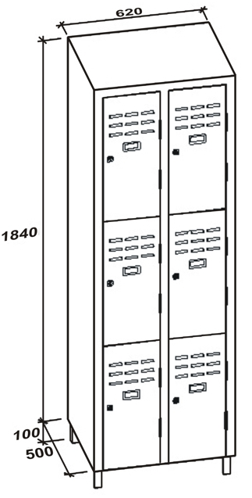
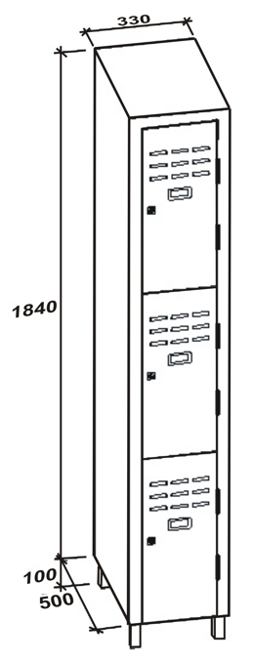
VIOMETAL 1/3 DOOR LOCKERS
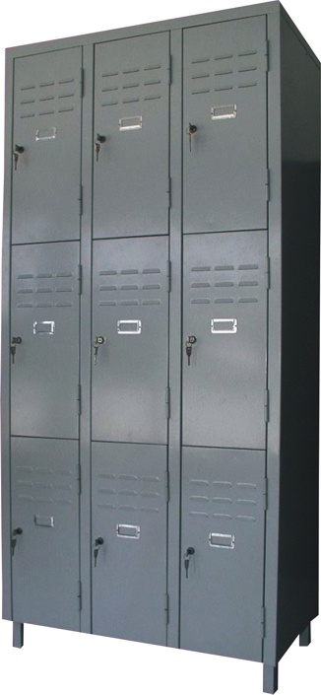

9TD
6TD
3TD

Code | Width in mm | Depth in mm | Height in mm | Description | Price
VL/3TD | 330 | 500 | 1940 | THREE 1/3 DOORS | €245.00+VAT (=€286.65)
VL/6TD | 620 | 500 | 1940 | SIX 1/3 DOORS | €405.00+VAT (=€473.85)
VL/9TD | 910 | 500 | 1940 | NINE 1/3 DOORS | €575.00+VAT (=€672.75)

Ref. V018

OFFICE FURNITURE, MOBILE SYSTEMS, STORAGE SYSTEMS, SHELVING SYSTEMS, SAFES & VAULTS

