
NICOSIA HEAD OFFICE
P.O.Box 21212, 1504 Nicosia. Cyprus
Tel: +357-22354744, Fax: +357-22354932
LIMASSOL OFFICE
Tel: +357-25589913, Fax: +357-25586407
e-mail: viometal@logosnet.cy.net
web: www.viometal.net
VIOMETAL LTD
A. V a r n a v i d e s
Manufacturing & Engineering

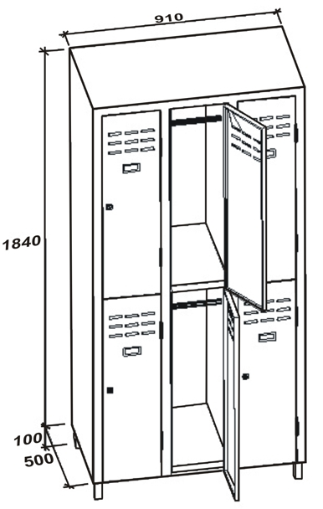
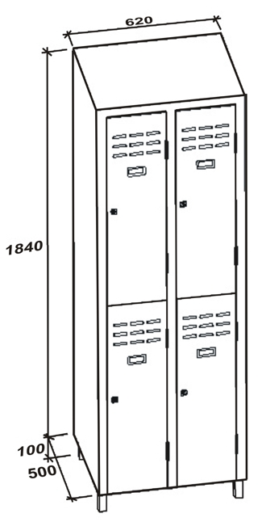
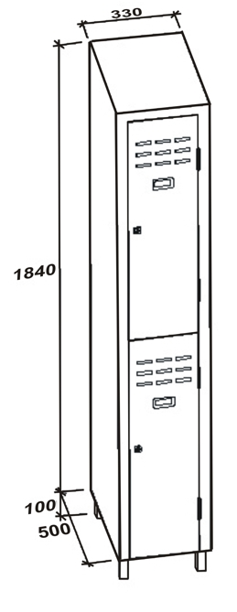
VIOMETAL HALF DOOR LOCKERS
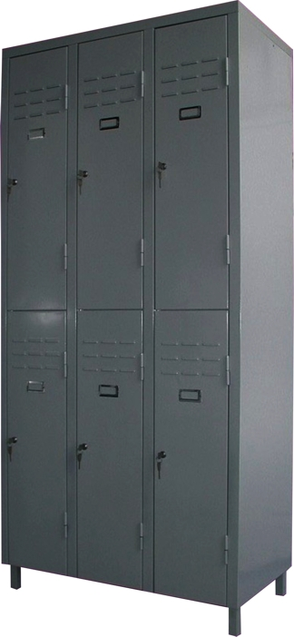

4HD
2HD

Code | Width in mm | Depth in mm | Height in mm | Description | Price
VL/2HD | 330 | 500 | 1940 | TWO HALF DOORS | €210.00+VAT (=€245.70)
VL/4HD | 620 | 500 | 1940 | FOUR HALF DOORS | €330.00+VAT (=€386.10)
VL/6HD | 910 | 500 | 1940 | SIX HALF DOORS | €465.00+VAT (=€544.05)
6HD

Ref. V017
L&C 02
OFFICE FURNITURE, MOBILE SYSTEMS, STORAGE SYSTEMS, SHELVING SYSTEMS, SAFES & VAULTS

