
NICOSIA HEAD OFFICE
P.O.Box 21212, 1504 Nicosia. Cyprus
Tel: +357-22354744, Fax: +357-22354932
LIMASSOL OFFICE
Tel: +357-25589913, Fax: +357-25586407
e-mail: viometal@logosnet.cy.net
web: www.viometal.net
VIOMETAL LTD
A. V a r n a v i d e s
Manufacturing & Engineering

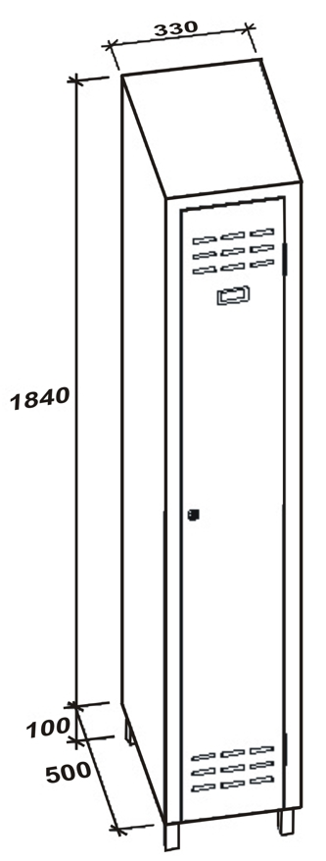
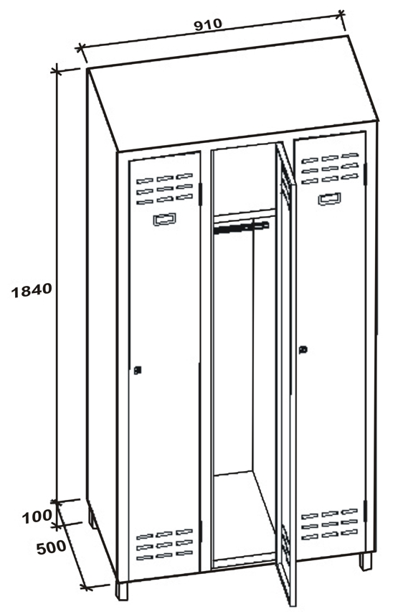
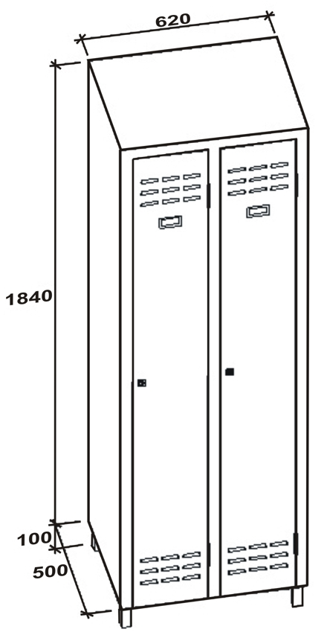
VIOMETAL LONG DOOR LOCKERS
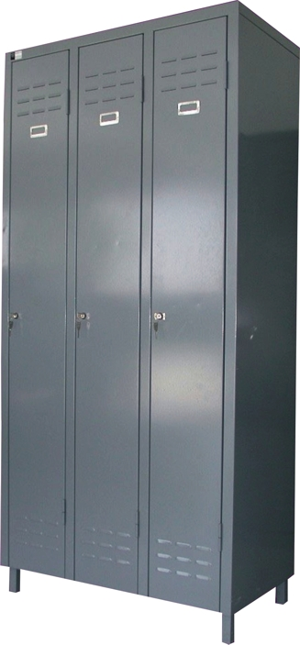

1LD
2LD
3LD

Code | Width in mm | Depth in mm | Height in mm | Description | Price
VL/1LD | 330 | 500 | 1940 | ONE LONG DOOR | €180.00+VAT (=€210.60)
VL/2LD | 620 | 500 | 1940 | TWO LONG DOORS | €280.00+VAT (=€327.60)
VL/3LD | 910 | 500 | 1940 | THREE LONG DOORS | €350.00+VAT (=€409.50)

Ref. V016
L&C 01
OFFICE FURNITURE, MOBILE SYSTEMS, STORAGE SYSTEMS, SHELVING SYSTEMS, SAFES & VAULTS

