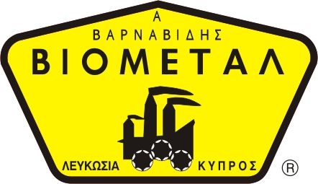
NICOSIA HEAD OFFICE
P.O.Box 21212, 1504 Nicosia. Cyprus
Tel: +357-22354744, Fax: +357-22354932
LIMASSOL OFFICE
Tel: +357-25589913, Fax: +357-25586407
e-mail: viometal@logosnet.cy.net
web: www.viometal.net
VIOMETAL LTD
A. V a r n a v i d e s
Manufacturing & Engineering

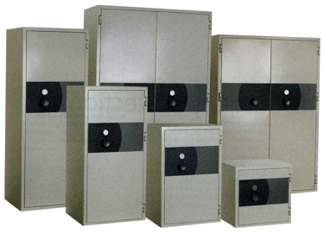
KASO PK-400 Fire Safes
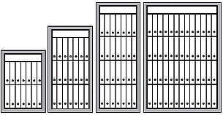

Model | PK-420E | PK-430A | PK-440E | PK-480A
External mm  Height  Width  Depth  Internal mm  Height  Width  Depth  Volume  Weight kg  A4-file capacity (pcs)  Price | 1030  670  580  840  485  360  149  205  12-18  €2300+VAT | 1380  670  580  1190  485  360  211  260  18-27  €2600+VAT | 1730  670  580  1540  485  360  273  315  24-36  €3360+VAT | 1730  1160  580  1540  970  360  546  495  48-76  €4670+VAT

• Modern design and wide range of models for multiple storage
needs
• 120 minutes fire protection according to NT FIRE 017 - 120 Paper
• Burglary protection according to European Standard EN 14450
S1(ECB-S)
• Security locking system against burglary, theft and unauthorized
access
• Over half a century experience in tested fire security products
    - Prices do not include any additional costs for forklift lifting expenses.

Ref. V015
SAFES 14
OFFICE FURNITURE, MOBILE SYSTEMS, STORAGE SYSTEMS, SHELVING SYSTEMS, SAFES & VAULTS

