
NICOSIA HEAD OFFICE
P.O.Box 21212, 1504 Nicosia. Cyprus
Tel: +357-22354744, Fax: +357-22354932
LIMASSOL OFFICE
Tel: +357-25589913, Fax: +357-25586407
e-mail: viometal@logosnet.cy.net
web: www.viometal.net
VIOMETAL LTD
A. V a r n a v i d e s
Manufacturing & Engineering

HOTEL ROOMSAFE 30x30x20H

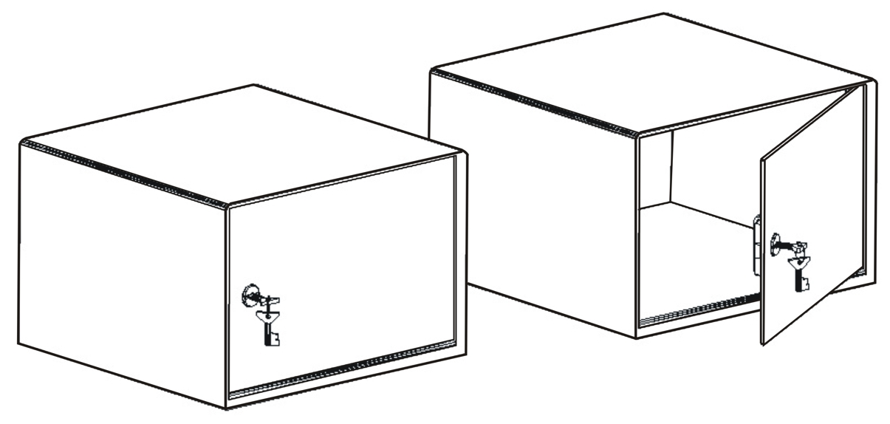

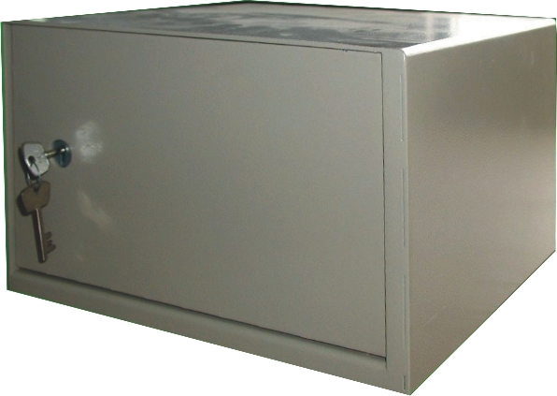

DESCRIPTION
Code: HRS 30x30x20H
Dimensions: 30W x 30D x 20H
Body Thickness: 2mm
Door Thickness: 5mm

High Security Key Lock
Carpet on the base inside
Price: €80.00+VAT (=€93.60)

Ref. V013
SAFES 20

OFFICE FURNITURE, MOBILE SYSTEMS, STORAGE SYSTEMS, SHELVING SYSTEMS, SAFES & VAULTS

