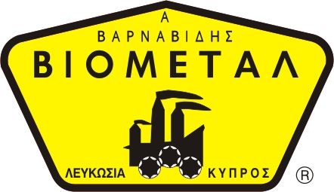
NICOSIA HEAD OFFICE
P.O.Box 21212, 1504 Nicosia. Cyprus
Tel: +357-22354744, Fax: +357-22354932
LIMASSOL OFFICE
Tel: +357-25589913, Fax: +357-25586407
e-mail: viometal@logosnet.cy.net
web: www.viometal.net
VIOMETAL LTD
A. V a r n a v i d e s
Manufacturing & Engineering

KASO BIG E1-05
EUROSAFE
for small offices, shops and restaurants
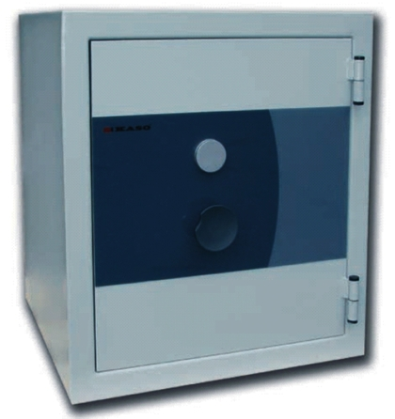
- Burglary protection Grade I,
- EN 1143-1 (ECB-S)

- Fire protection 60 minutes,
- NT Fire 017-60 Paper

External mm  Height  Width  Depth | 580  520  515
Internal mm  Height  Width  Depth | 415  350  300
Volume l | 44
Weight kg | 165

Designed for secure and convenient storage solution for shops,
small offices and restaurants.

Offering certified protection against multiple threats.

Proof of high quality of the manufacturing and design in accordance with the
ISO 9001:2000 quality management system.
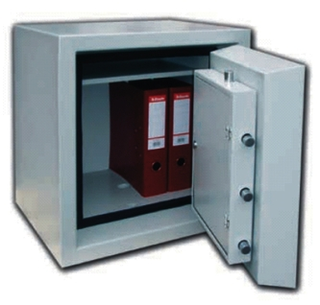

Standard options ____________
- Unpickable Mauer keylock
- Standard colour light grey
(RAL 7035)
- Floor anchoring hole and a bolt
- One shelf

Code: SAFEKASO
Price: €1,050.00 + VAT (€1,228.50)

Ref. V012

SAFES 13

OFFICE FURNITURE, MOBILE SYSTEMS, STORAGE SYSTEMS, SHELVING SYSTEMS, SAFES & VAULTS

