
NICOSIA HEAD OFFICE
P.O.Box 21212, 1504 Nicosia. Cyprus
Tel: +357-22354744, Fax: +357-22354932
LIMASSOL OFFICE
Tel: +357-25589913, Fax: +357-25586407
e-mail: viometal@logosnet.cy.net
web: www.viometal.net
VIOMETAL LTD
A. V a r n a v i d e s
Manufacturing & Engineering

BANK CASHIERS DEPOSIT LOCKERS
(Placed inside Strong Rooms)

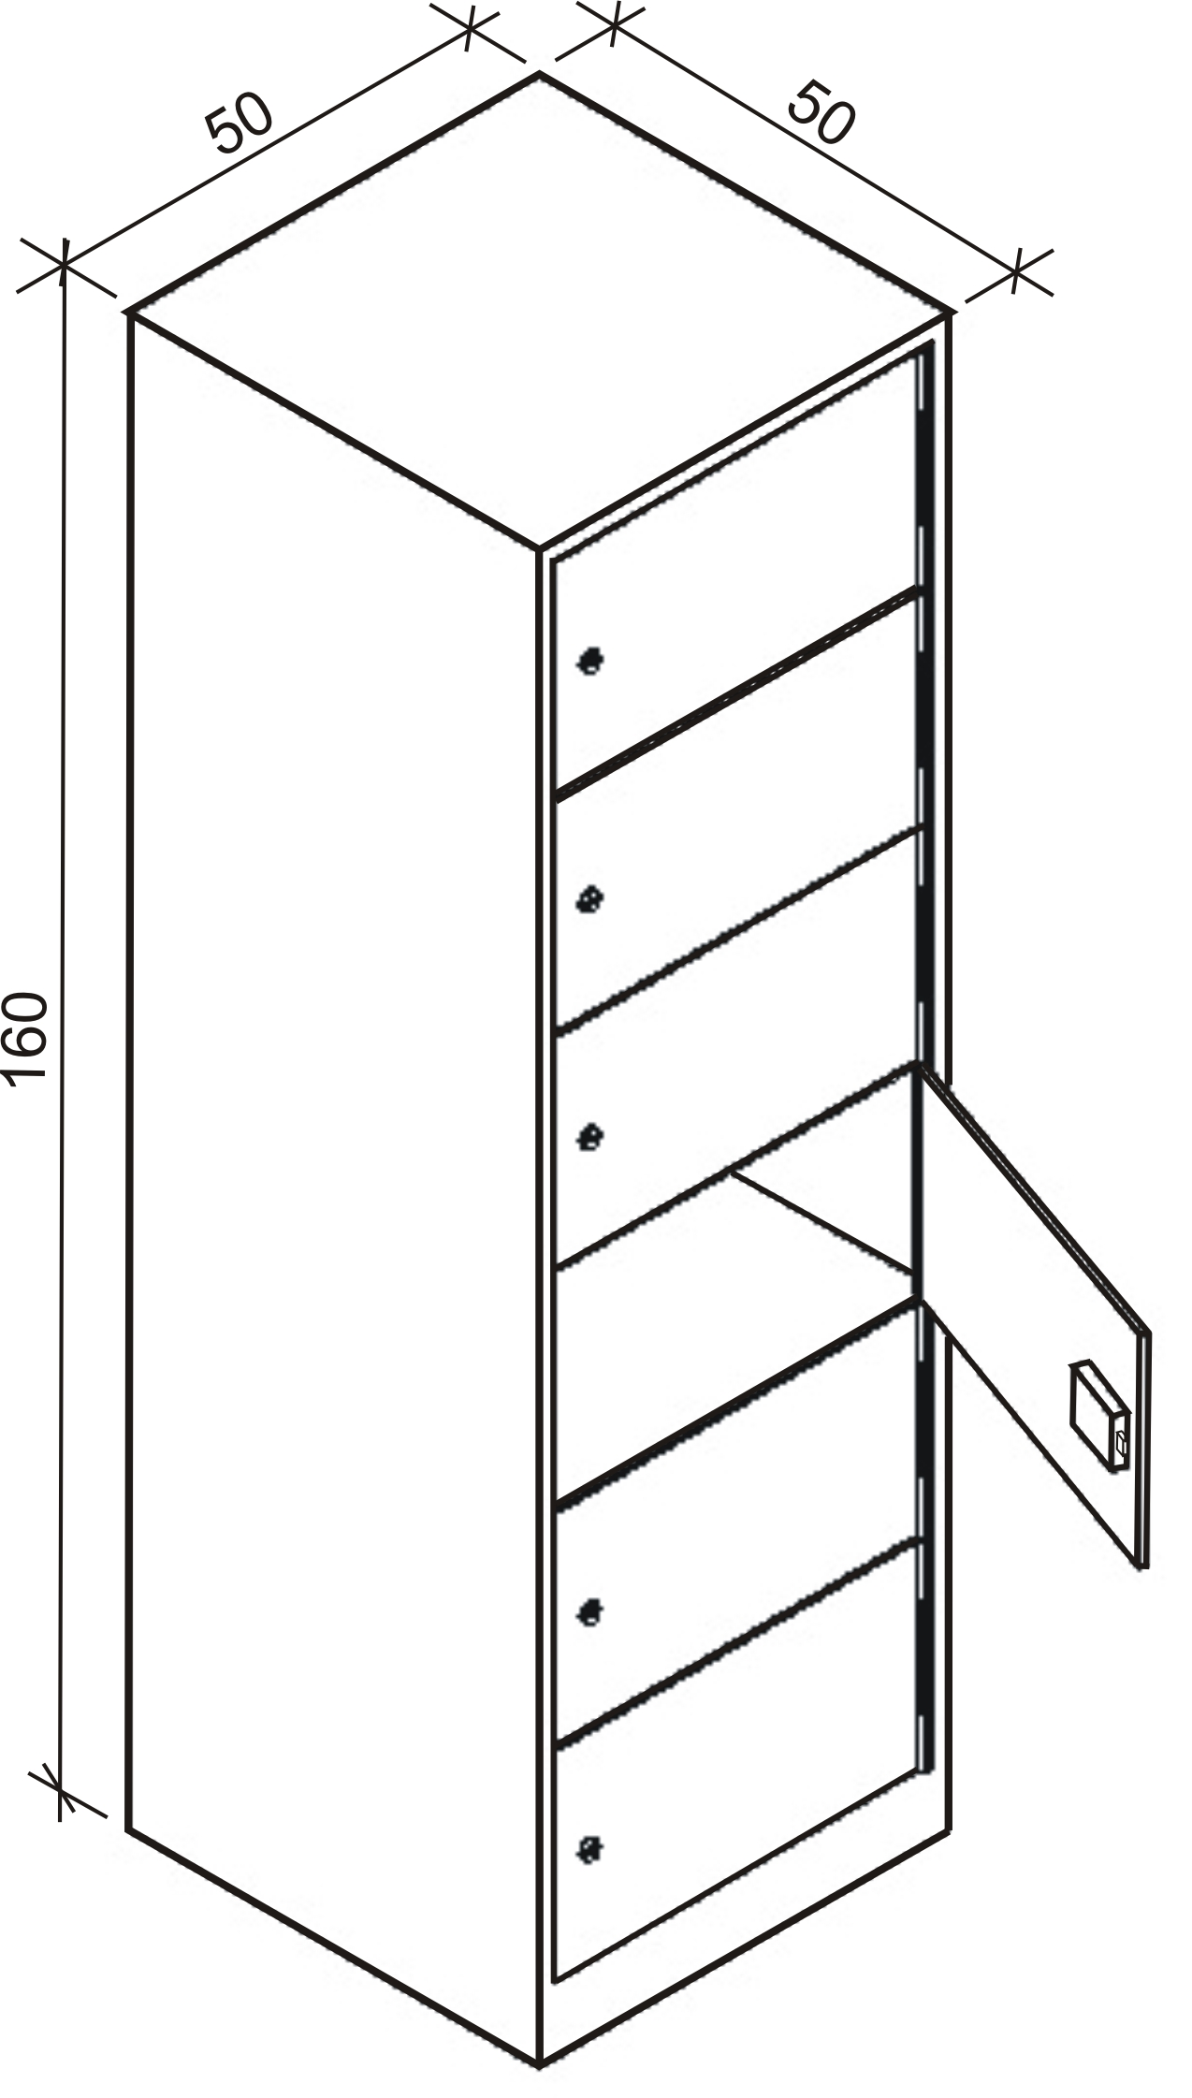

Ref. V011

DESCRIPTION
Code: BANKCDL
6 Lockers 50W x 50D x 160H
Body: 2mm thick, Door: 6mm thick
High security locks
Price: €1,280.00+VAT (=€1,497.60)

SAFES 18

OFFICE FURNITURE, MOBILE SYSTEMS, STORAGE SYSTEMS, SHELVING SYSTEMS, SAFES & VAULTS

