
NICOSIA HEAD OFFICE
P.O.Box 21212, 1504 Nicosia. Cyprus
Tel: +357-22354744, Fax: +357-22354932
LIMASSOL OFFICE
Tel: +357-25589913, Fax: +357-25586407
e-mail: viometal@logosnet.cy.net
web: www.viometal.net
VIOMETAL LTD
A. V a r n a v i d e s
Manufacturing & Engineering

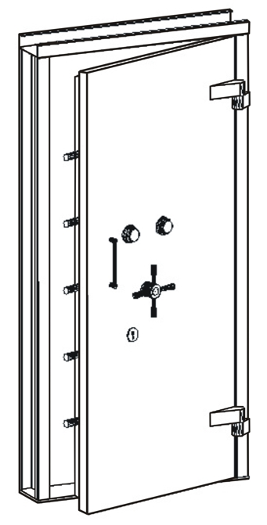
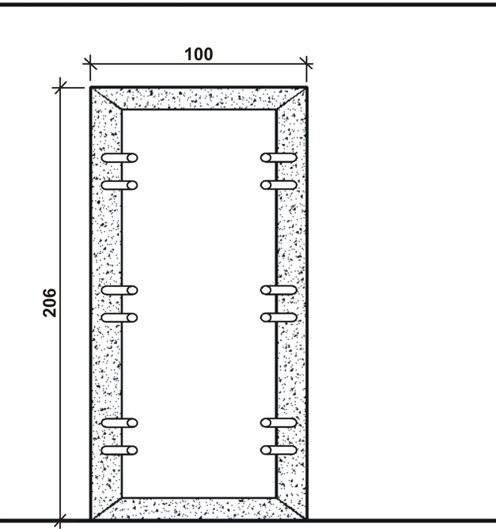
ΕΠΙΠΕΔΟ ΟΡΟΦΗΣ

STRONGROOM
DOOR

ΤΟΙΧΟΠΟΙΙΑ ΑΠΟ ΟΠΛΙΣΜΕΝΟ ΣΚΥΡΟΔΕΜΑ ΠΑΧΟΥΣ ΤΟΥΛΑΧΙΣΤΟΝ 20cm

12 ΣΙΔΕΡΑ Ø16 ΑΡΙΣΤΕΡΑ ΚΑΙ ΔΕΞΙΑ ΓΙΑ ΗΛΕΚΤΡΟΚΟΛΛΗΣΗ ΚΑΣΙΑΣ

ΤΕΛΕΙΩΜΕNO ΠΑΤΩΜΑ

Type | Fire Proof Strongroom Door – Class1
Code | FPSD1
Dimensions | 100Wx20Dx206H
Price | €4,275.00+VAT (=€5,001.75)

Ref. V010

    - Prices do not include any additional costs for forklift lifting expenses.
SAFES 23

OFFICE FURNITURE, MOBILE SYSTEMS, STORAGE SYSTEMS, SHELVING SYSTEMS, SAFES & VAULTS

