
NICOSIA HEAD OFFICE
P.O.Box 21212, 1504 Nicosia. Cyprus
Tel: +357-22354744, Fax: +357-22354932
LIMASSOL OFFICE
Tel: +357-25589913, Fax: +357-25586407
e-mail: viometal@logosnet.cy.net
web: www.viometal.net
VIOMETAL LTD
A. V a r n a v i d e s
Manufacturing & Engineering

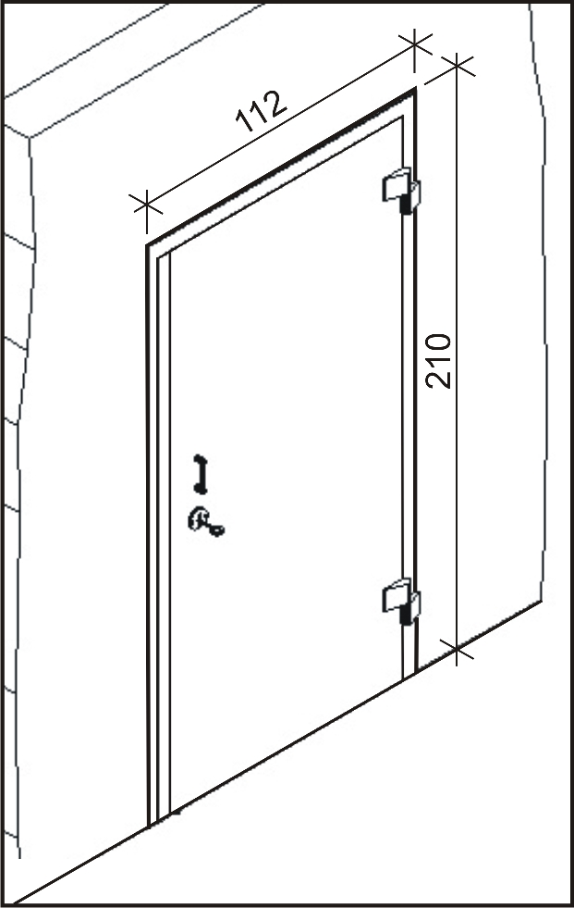

SECURITY DOOR
Wall

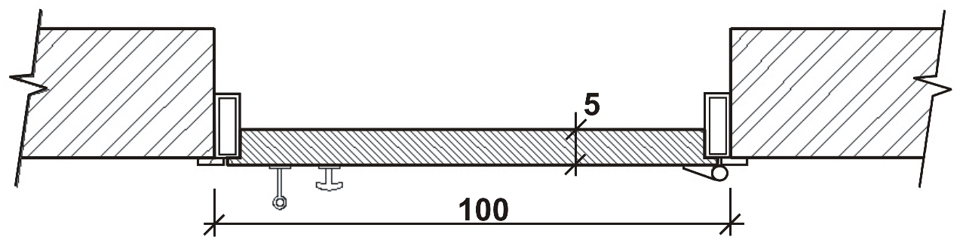

60x60x6thk.
L-Angle
SECTION
Code: FDOOR
Dim: 112cm(W) x 210cm(H)
Price: €2,000.00+VAT (€2,340.00)

Locking bolts ø20mm

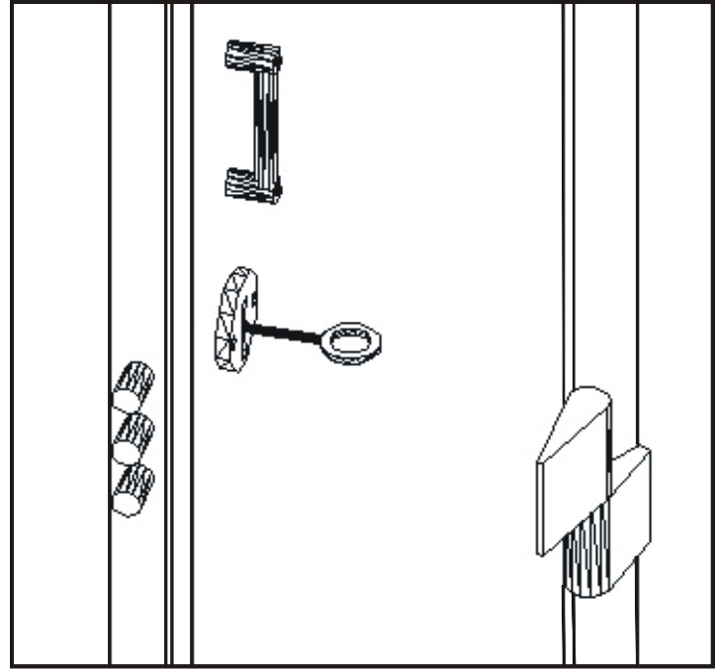
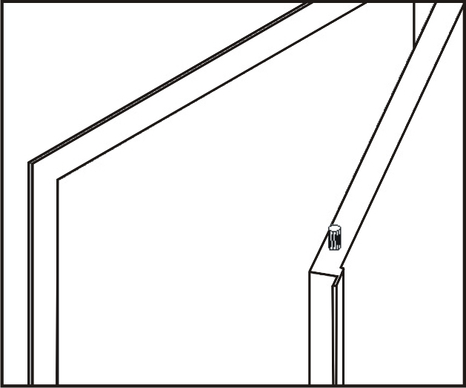

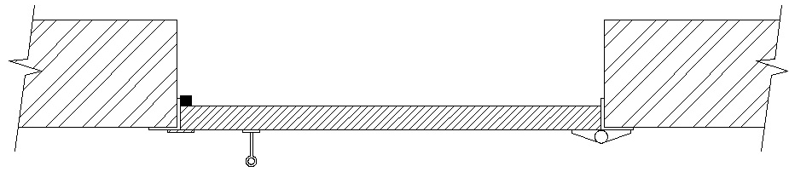

    - Prices do not include any additional costs for
forklift lifting expenses.

Ref. V009
SAFES 24
OFFICE FURNITURE, MOBILE SYSTEMS, STORAGE SYSTEMS, SHELVING SYSTEMS, SAFES & VAULTS

