
NICOSIA HEAD OFFICE
P.O.Box 21212, 1504 Nicosia. Cyprus
Tel: +357-22354744, Fax: +357-22354932
LIMASSOL OFFICE
Tel: +357-25589913, Fax: +357-25586407
e-mail: viometal@logosnet.cy.net
web: www.viometal.net
VIOMETAL LTD
A. V a r n a v i d e s
Manufacturing & Engineering

BANK SAFE DEPOSIT BOXES - BLOCK
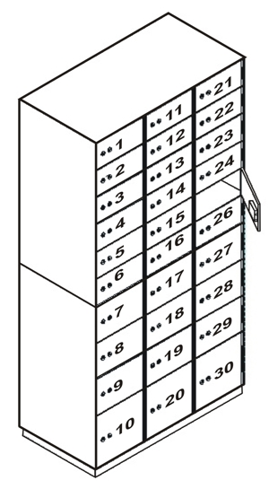
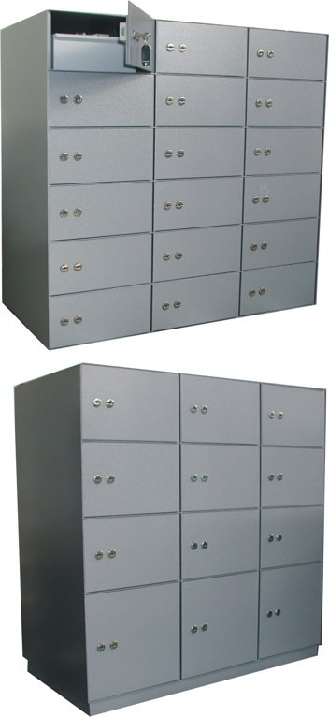

DESCRIPTION
Code: BANK SDB
- 3mm Thick Steel Body
- 8mm Thick Steel Doors
- Outside Dimensions: 97W x 50D x 189H
- Door Layout: 18 Small Doors - 30W x 15H
9 Medium Doors – 30W x 20H
3 Large Doors – 30W x 30H

- Lock: High Security Dual Control Lock (Germany)
- Trays: Open Metal Tray Inside Each Box.
Price: €5,550.00 + VAT (=€6,493.50)

    - Prices do not include any additional costs for forklift lifting expenses.

Ref. V008
SAFES 17

OFFICE FURNITURE, MOBILE SYSTEMS, STORAGE SYSTEMS, SHELVING SYSTEMS, SAFES & VAULTS

